20 | The Lymphatic System  and Immunity
In the last chapter, we looked at the structure and function of blood, including leukocytes, which function in immunity. Now we look at these cells more closely as we explore the lymphatic system and the organs, cells, and proteins that function in immunity.
What Do You Think You Already Know?
Try to answer the following questions before proceeding to the next section. If you’re unsure of the correct answers, give it your best attempt based on previous courses, previous chapters, or just your general knowledge.
• Why does a healthcare provider palpate (feel) your neck when you are sick?

• What causes flu-like symptoms when we get sick?

• What is the purpose of a fever?

Module 20.1: Structure and Function of the Lymphatic System
Module 20.1 in your text introduces you to the structure and function of the cells, tissues, and organs of the lymphatic system. By the end of the module, you should be able to do the following:
1. Describe the major functions of the lymphatic system.
2. Compare and contrast lymphatic vessels and blood vessels in terms of structure and function.
3. Explain the mechanisms of lymph formation, and trace the pathway of lymph circulation through the body.
4. Describe the basic structure and cellular composition of lymphatic tissue, and relate them to the overall functions of the lymphatic system.
5. Describe the structures and functions of the lymphoid organs.

Build Your Own Glossary
Following is a table listing key terms from Module 20.1. Before you read the module, use the glossary at the back of your book or look through the module to define the following terms.
Key Terms for Module 20.1
Term | Definition
Lymph
Lymphatic vessels
Lymphatic capillaries
Lymphoid tissue
Dendritic cells
Reticular cells
Mucosa-associated lymphatic tissue (MALT)
Lymphoid follicles
Tonsils (pharyngeal, lingual, and palatine)
Lymph node
Spleen
Thymus

Outline It: Note Taking
Outline Module 20.1 using the note-taking technique you practiced in the introductory chapter (see Chapter 1). (The template is available in the study area of Mastering A&P.)
Identify It: Structures of the Lymphatic System
Identify and color-code each component of the lymphatic system in Figure 20.1.

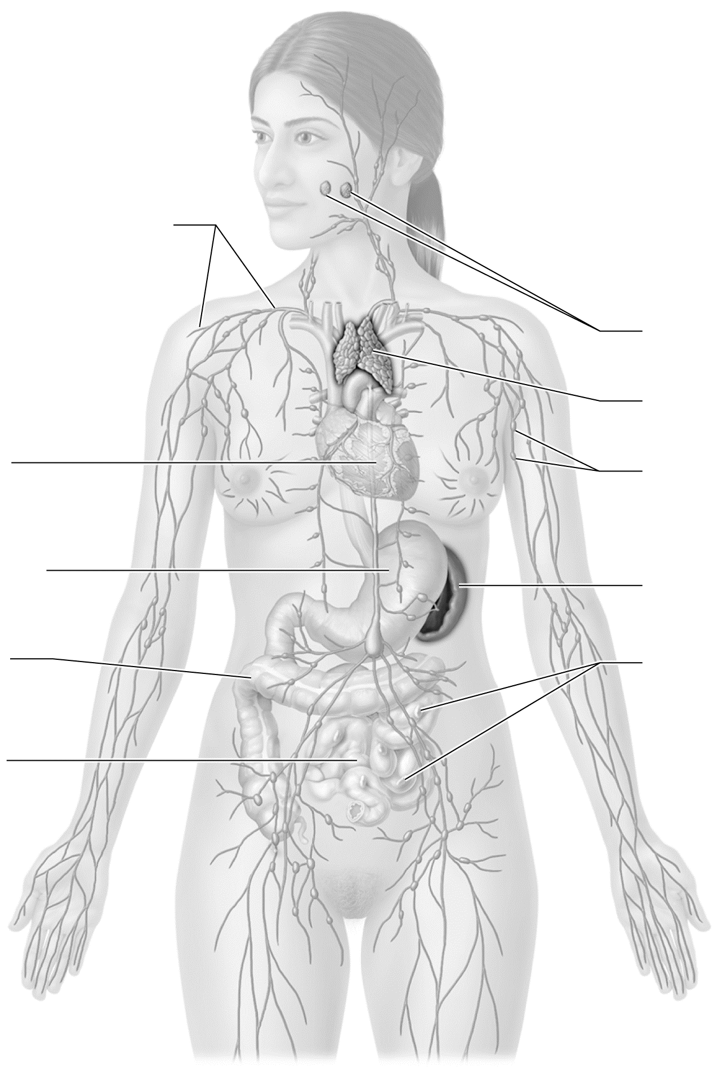

Figure 20.1 The organs of the lymphatic system.
Key Concept: Why does severe swelling result when lymphatic vessels are blocked or damaged?

Identify It: Main Lymph Ducts and Trunks
Identify and color-code the main lymph ducts and trunks in Figure 20.2. Then, list the body regions that each duct and trunk drains.
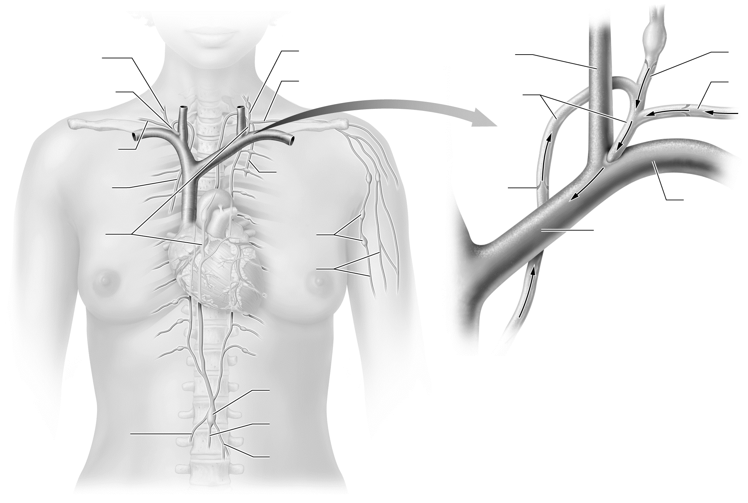
Figure 20.2 Main lymph ducts and trunks.

Build Your Own Summary Table: Cells, Tissues, and Organs of the Lymphatic System
As you read Module 20.1, build your own summary table about the different types of cells, tissues, and organs that make up the lymphatic system by filling in the information in the following table.
Summary of Lymphatic Cells, Tissues, and Organs
Lymphatic Structure | Description/Location | Function
Cells
Leukocytes
Dendritic cells
Reticular cells
Mucosa-Associated Lymphatic Tissue
Peyer’s patches
Appendix
Pharyngeal tonsil
Lingual tonsil
Palatine tonsils
Organs
Lymph nodes
Spleen
Thymus
Key Concept: Why do lymph nodes get swollen when you are sick?

Module 20.2: Overview of the Immune System
Now we look at some of the fundamental principles of immunity. When you finish this module, you should be able to do the following:
1. Identify the differences between innate and adaptive immunity, and explain how the two types of immunity work together.
2. Describe the basic differences between antibody-mediated and cell-mediated immunity.
3. Describe the roles that surface barriers play in immunity.
4. Describe the cells and proteins that make up the immune system.
5. Explain how the immune and lymphatic systems are connected structurally and functionally.
Build Your Own Glossary
Following is a table listing key terms from Module 20.2. Before you read the module, use the glossary at the back of your book or look through the module to define the following terms.
Key Terms for Module 20.2
Term | Definition
Innate immunity
Adaptive immunity
Antigen
Cell-mediated immunity
Antibody-mediated immunity
Surface barriers
Phagocyte
Natural killer cell
Cytokine

Outline It: Note Taking
Outline Module 20.2 using the note-taking technique you practiced in the introductory chapter (see Chapter 1). (The template is available in the study area of Mastering A&P.)
Key Concept: When you cut your finger, which line of defense is compromised? Why do we cover a wound with a bandage?

Practice It: Types of Immunity
Identify each of the following statements as being a property of either innate immunity or adaptive immunity.
• Requires 3 to 5 days to mount a response ______________________
• Brought about by T and B lymphocytes ______________________
• Requires no stimulus to produce; already present in the blood ______________________
• Responds to unique antigens ______________________
• Responds quickly to cellular injury; the dominant response in the first 12 hours ______________________
• Has the capacity for immunological memory ______________________
Complete It: Overview of Immunity
Fill in the blanks to complete the following paragraphs that describe the basic principles of the immune system.
The first line of defense consists of ________________ ________________ that prevent the entry of pathogens into the body. Certain surface barriers secrete substances that deter the growth of, kill, or trap pathogens, such as ________________ in the skin, ________________ in mucous membranes, and ________________ in the stomach.
The second line of defense is also known as ________________ ________________ and the third line as ________________ ________________. The main cells of both lines are ________________. Many cells of the second line ingest pathogens or damaged cells by the process of ________________. The other components of both lines are ________________, such as ________________, ________________, and ________________.
Key Concept: Why does a problem with the lymphatic system potentially lead to a problem with the immune system?

Module 20.3: Innate Immunity: Internal Defenses
We now take a look at the defenses provided by the cells and proteins of innate immunity. When you complete this module, you should be able to do the following:
1. Describe the roles that phagocytic and nonphagocytic cells and plasma proteins such as complement and interferon play in innate immunity.
2. Walk through the stages of the inflammatory response and describe its purpose.
3. Describe the process by which fever is generated and explain its purpose.
Build Your Own Glossary
Following is a table listing key terms from Module 20.3. Before you read the module, use the glossary at the back of your book or look through the module to define the following terms.
Key Terms of Module 20.3
Term | Definition
Antigen-presenting cell
Neutrophil
Eosinophil
Basophil
Mast cell
Complement system
Interferons
Inflammatory response
Fever
Pyrogen
Outline It: Note Taking
Outline Module 20.3 using the note-taking technique you practiced in the introductory chapter (see Chapter 1). (The template is available in the study area of Mastering A&P.)

Key Concept: What often causes flu-like symptoms when one is infected with a pathogen?

Describe It: The Inflammatory Response, Part 1
Describe the sequence of events of the first part of the inflammatory response in Figure 20.3. In addition, label and color-code each important component of the process.
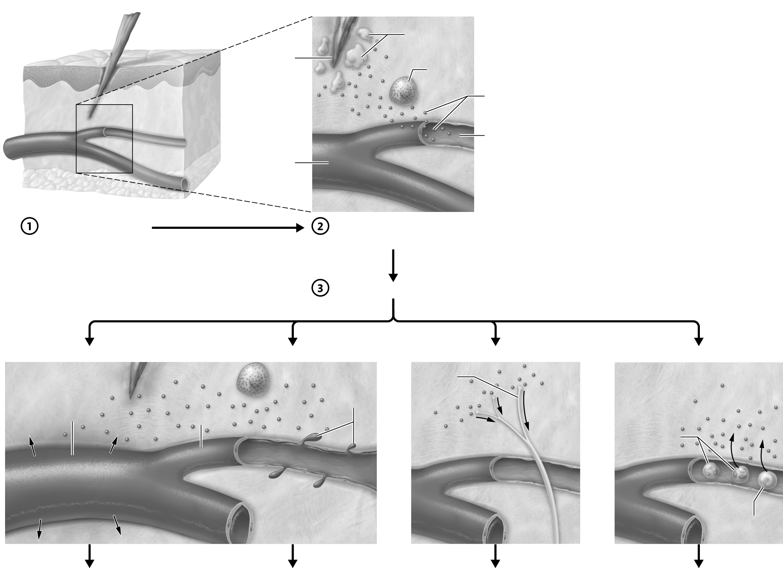

Figure 20.3 The inflammatory response, part 1.

Describe It: The Inflammatory Response, Part 2
Describe the sequence of events of the second part of the inflammatory response in Figure 20.4. In addition, label and color-code each important component of the process.
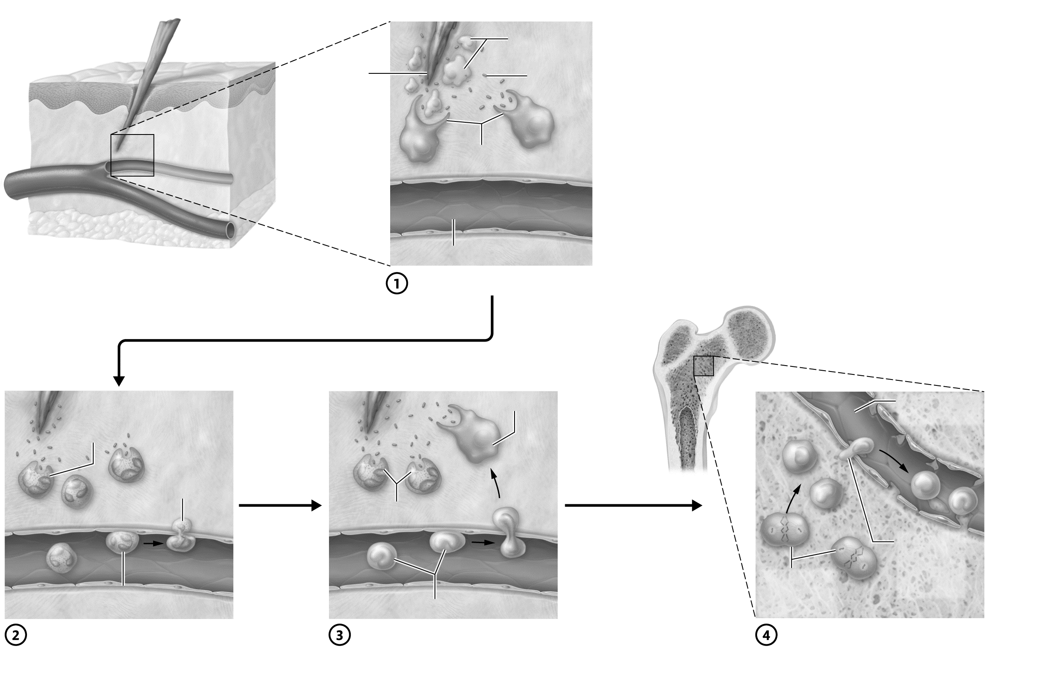
Figure 20.4 The inflammatory response, part 2.
Key Concept: What causes a fever?

Key Concept: Your classmate insists that since your patient has a fever, she must have an infection because the elevated temperature of fever kills the bacteria. Explain to your classmate why this is wrong.

Module 20.4: Adaptive Immunity: Cell-Mediated Immunity
Module 20.4 in your text explores the functions of the cells of the first arm of adaptive immunity: cell-mediated immunity. At the end of this module, you should be able to do the following:
1. Explain the differences between antigens, haptens, antigenic determinants, and self antigens.
2. Describe the processes of T lymphocyte activation, differentiation, and proliferation, including the roles of antigen-presenting cells.
3. Compare and contrast the classes of T lymphocytes.
4. Describe the two types of major histocompatibility complex antigens, and explain their functions.
5. Describe the purpose of immunological memory, and explain how it develops.
6. Describe the process by which a transplanted organ or tissue is rejected, and explain how this may be prevented.
Build Your Own Glossary
Following is a table listing key terms from Module 20.4. Before you read the module, use the glossary at the back of your book or look through the module to define the following terms.
Terms of Module 20.4
Term | Definition
Helper T cell
Cytotoxic T cell
Immunocompetent
Self antigen
Class I MHC molecule
Class II MHC molecule
Immunological memory

Outline It: Note Taking
Outline Module 20.4 using the note-taking technique you practiced in the introductory chapter (see Chapter 1). (The template is available in the study area of Mastering A&P.)
Key Concept: What is a T cell clone? How is each T cell clone genetically unique? Which clones are destroyed in the thymus, and why?

Complete It: T Cells and MHC Molecules
Fill in the blanks to complete the following paragraph that describes the properties of MHC molecules and their relationship to cytotoxic and helper T cells.
The T cell receptor can only bind to portions of antigen bound to ________________ ________________ ________________ on the surface of cells. Nearly all cells have ________________ ________________ ________________ molecules on their cell surface that display ________________ antigens. ________________ ________________ ________________ molecules are found only on antigen-presenting cells and display ________________ antigens. T_{H} cells bind to ________________ ________________ ________________ molecules only, whereas T_{C} cells bind to ________________ ________________ ________________.

Describe It: Display of MHC Molecules
Describe the sequence of events by which class I and class II MHC molecules are displayed in Figure 20.5. In addition, label and color-code each important component of the process.
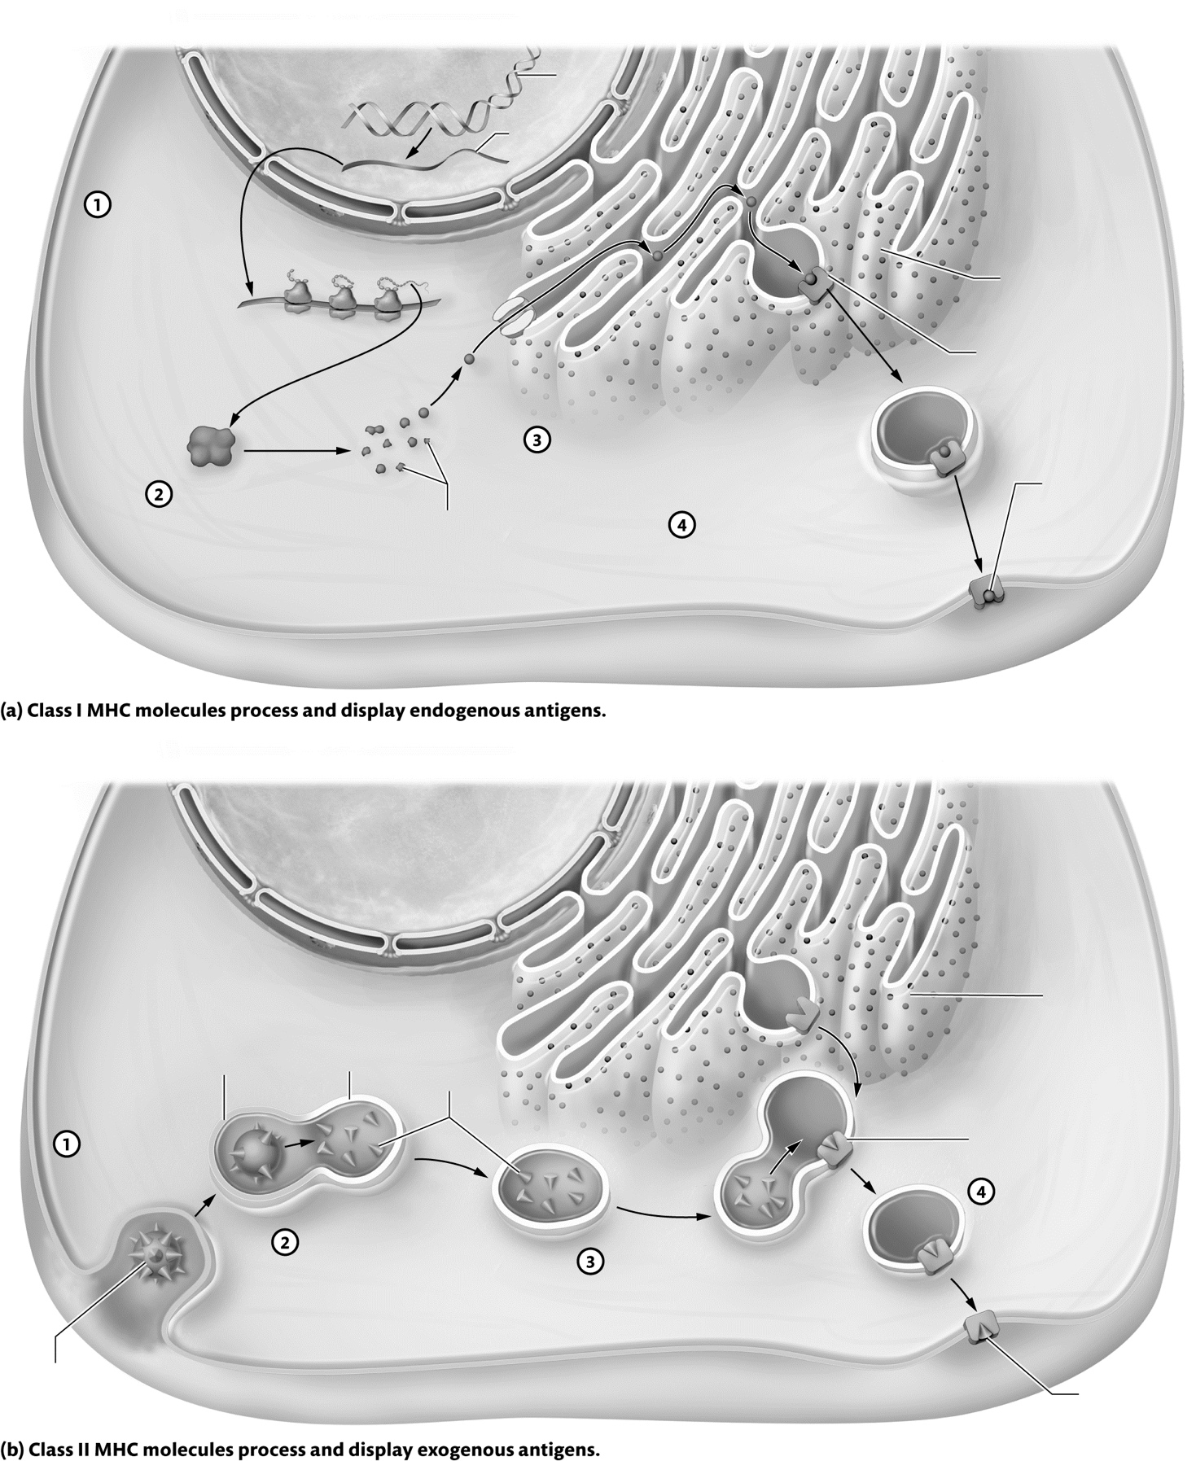

Figure 20.5 Antigen processing and display by MHC molecules.
Describe It: T Cell Activation
Describe the sequence of events by which T_{C} and T_{H} cells are activated in Figure 20.6. In addition, label and color-code each component of the process.

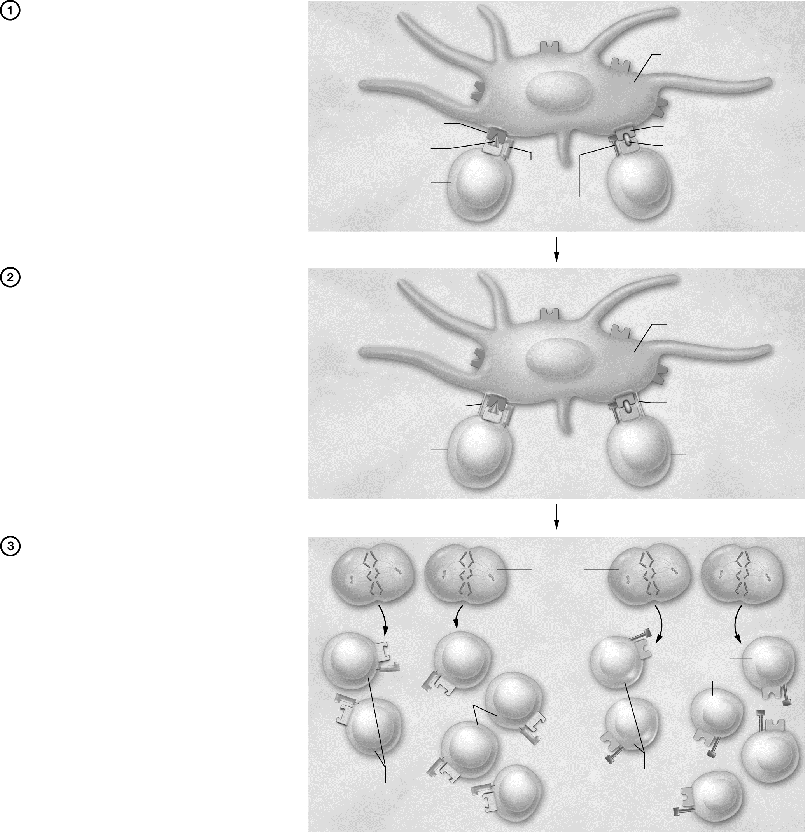

Figure 20.6 T cell activation.
Key Concept: Why are both class I and class II MHC molecules needed?

Practice It: Functions of T_{H} and T_{C} Cells
Identify each of the following statements as being a function of T_{H} cells or T_{C} cells.
• Releases the enzyme perforin, which catalyzes reactions to perforate the target cell membrane ____________
• Secretes interleukin-2 to activate T_{C} cells ____________
• Directly binds and stimulates B cells ____________
• Detects cancer cells, foreign cells, and cells infected with intracellular pathogens ____________
• Stimulates macrophages to become more efficient phagocytes ____________
• Releases enzymes that catalyze the destruction of a target cell’s DNA ____________
Key Concept: Why does so much of the immune system malfunction if T_{H} cells are not working properly?

Module 20.5: Adaptive Immunity: Antibody-Mediated Immunity
This module examines the second arm of adaptive immunity: antibody-mediated immunity. At the end of this module, you should be able to do the following:
1. Describe the process of B cell activation and proliferation.
2. Describe the five major classes of antibodies, and explain their structure and functions.
3. Compare and contrast the primary and secondary immune responses.
4. Explain how vaccinations induce immunity.
5. Compare and contrast active immunity and passive immunity.

Build Your Own Glossary
Following is a table listing key terms from Module 20.5. Before you read the module, use the glossary at the back of your book or look through the module to define the following terms.
Key Terms of Module 20.5
Term | Definition
Antibody
Plasma cell
Memory B cell
Agglutination
Precipitation
Opsonization
Neutralization (of antigen)
Primary immune response
Secondary immune response
Vaccination
Active immunity
Passive immunity

Outline It: Note Taking
Outline Module 20.5 using the note-taking technique you practiced in the introductory chapter (see Chapter 1). (The template is available in the study area of Mastering A&P.)
Key Concept: Where do B cells mature? Why do only about 10% of the cells complete their maturation process?

Describe It: B Cell Activation
Describe the sequence of events by which B cells are activated in Figure 20.7. In addition, label and color-code each important component of the process.
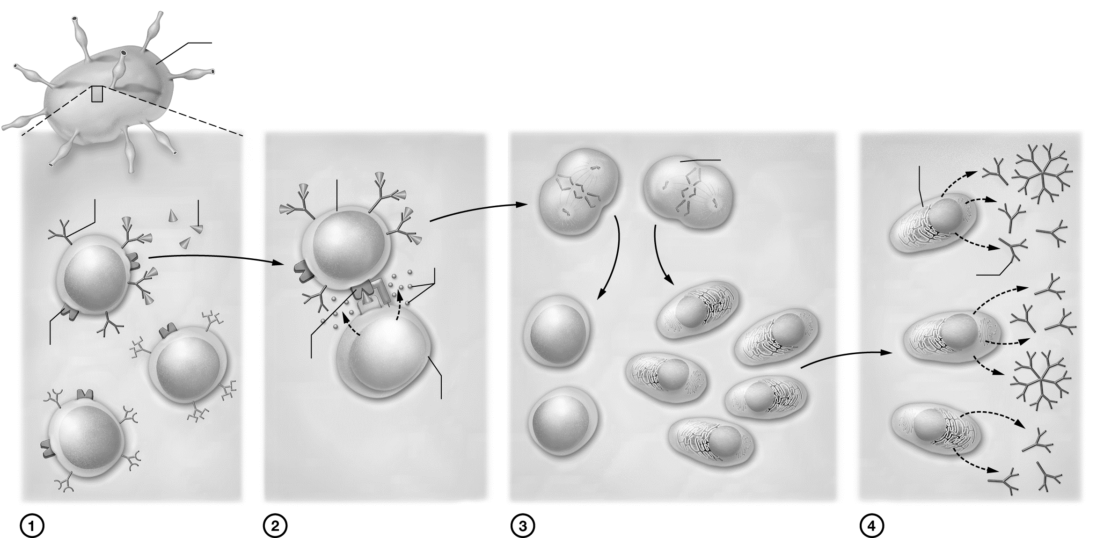

Figure 20.7 B cell activation.
Key Concept: How do plasma cells and memory B cells differ?

Draw It: Functions of Antibodies
Draw and describe the functions of antibodies. Label and color any important structures of the processes.

Build Your Own Summary Table: Antibody Classes
Build your own summary table about the different classes of antibodies by filling in the information in the following table. Take advantage of the dual coding technique by drawing the antibodies in the “structure” column.
Antibody Classes
Class | Structure | Functions/Properties
IgG
IgA
IgM
IgE
IgD

Key Concept: You have just been envenomated by a spider and the physician gives you pre-formed antibodies to the venom. Is this active or passive immunity? Six months later, you find that your antibody titer to the venom is still high. Is this due to active or passive immunity? Explain.

Key Concept: Your friend insists that she gets the flu every time she gets a flu shot. However, the flu vaccine contains killed viruses. What do you tell her?


Mix It Up: Bring It Back by Building Your Own Summary Table of Cells and Proteins of Innate Immunity
Let’s Mix It Up by building your own summary table of the different types of the cells and proteins of innate immunity. In the “Description” column, take advantage of the dual coding technique by drawing the cell or protein with colored pencils where appropriate.
Cells and Proteins of Innate Immunity
Cell or Protein | Description | Functions
Cells
Macrophages

Cell or Protein | Description | Functions
Cells
Neutrophils
Eosinophils
NK cells
Dendritic cells
Basophils
Mast cells
Proteins
Complement
Cell or Protein | Description | Functions
Proteins
Tumor necrosis factor
Interferons
Interleukins

Module 20.6: Putting It All Together: The Big Picture of the Immune Response
None of the parts of the immune system can function in isolation—all components must work with one another to protect the body from pathogens. So now we put the pieces together and see the big picture of the immune response. By the end of the module, you should be able to do the following:
1. Describe how the immune and lymphatic systems work together to respond to internal and external threats.
2. Explain how the immune response differs for different types of threats.
3. Describe the immune response to cancerous cells.
4. Explain how certain pathogens can evade the immune response.
Outline It: Note Taking
Outline Module 20.6 using the note-taking technique you practiced in the introductory chapter (see Chapter 1). (The template is available in the study area of Mastering A&P.)

Describe It: Response to a Viral Infection
Describe the sequence of events by which the immune system responds to a viral common cold in Figure 20.8. In addition, label and color-code each component of the process.
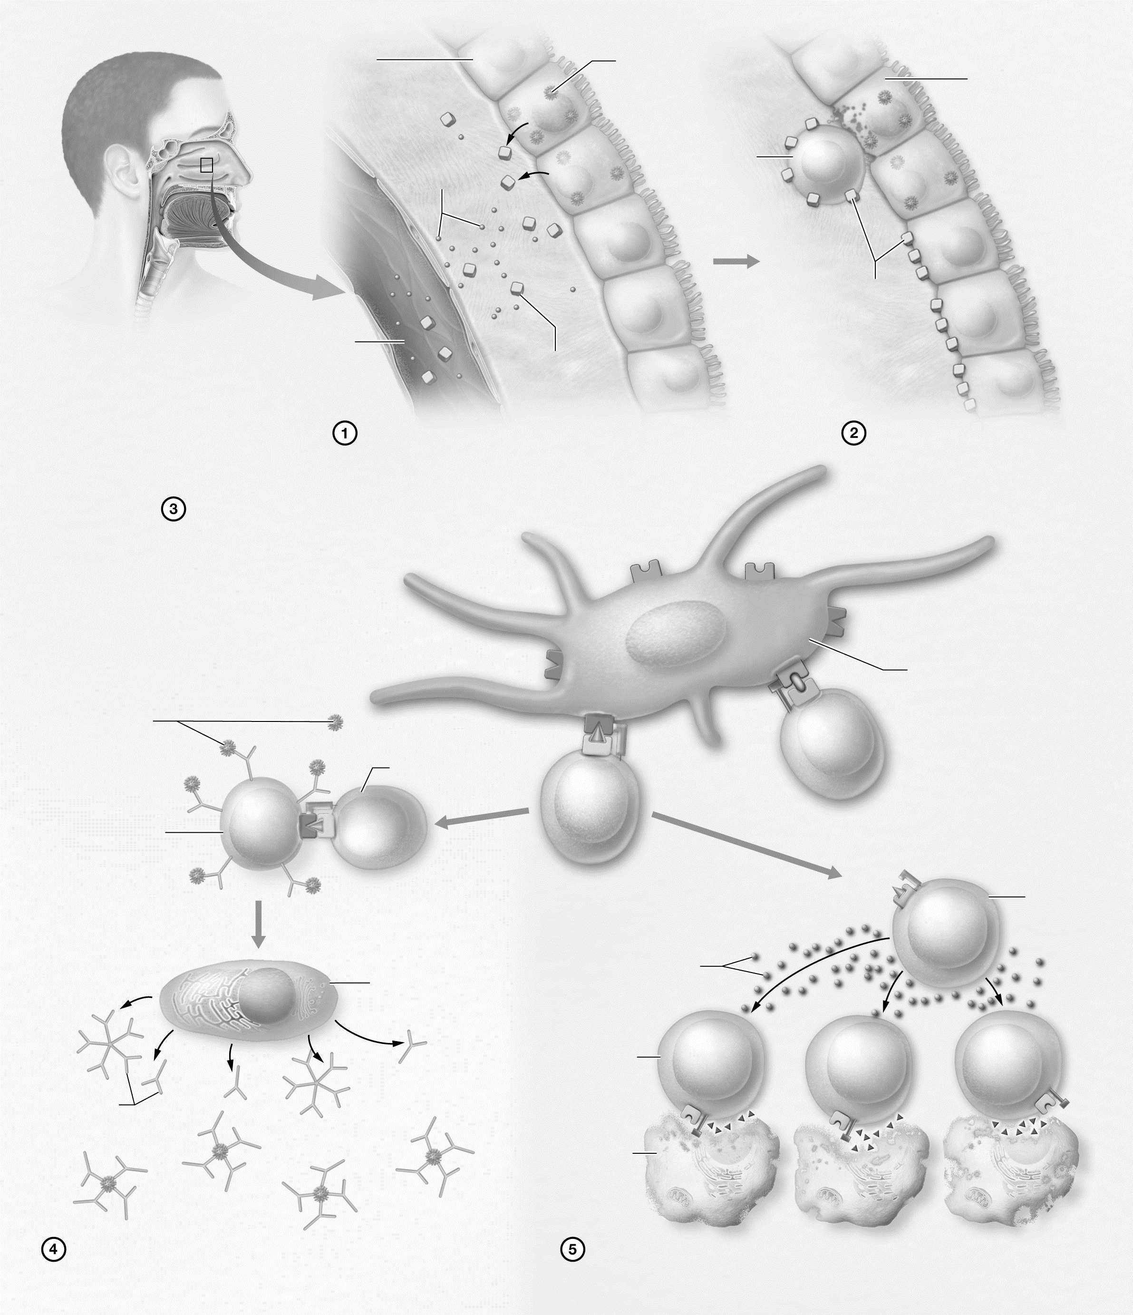

Figure 20.8 Immune response to the common cold.
Describe It: Response to a Bacterial Infection
Describe the sequence of events by which the immune system responds to a bacterial infection in Figure 20.9. In addition, label and color-code each component of the process.
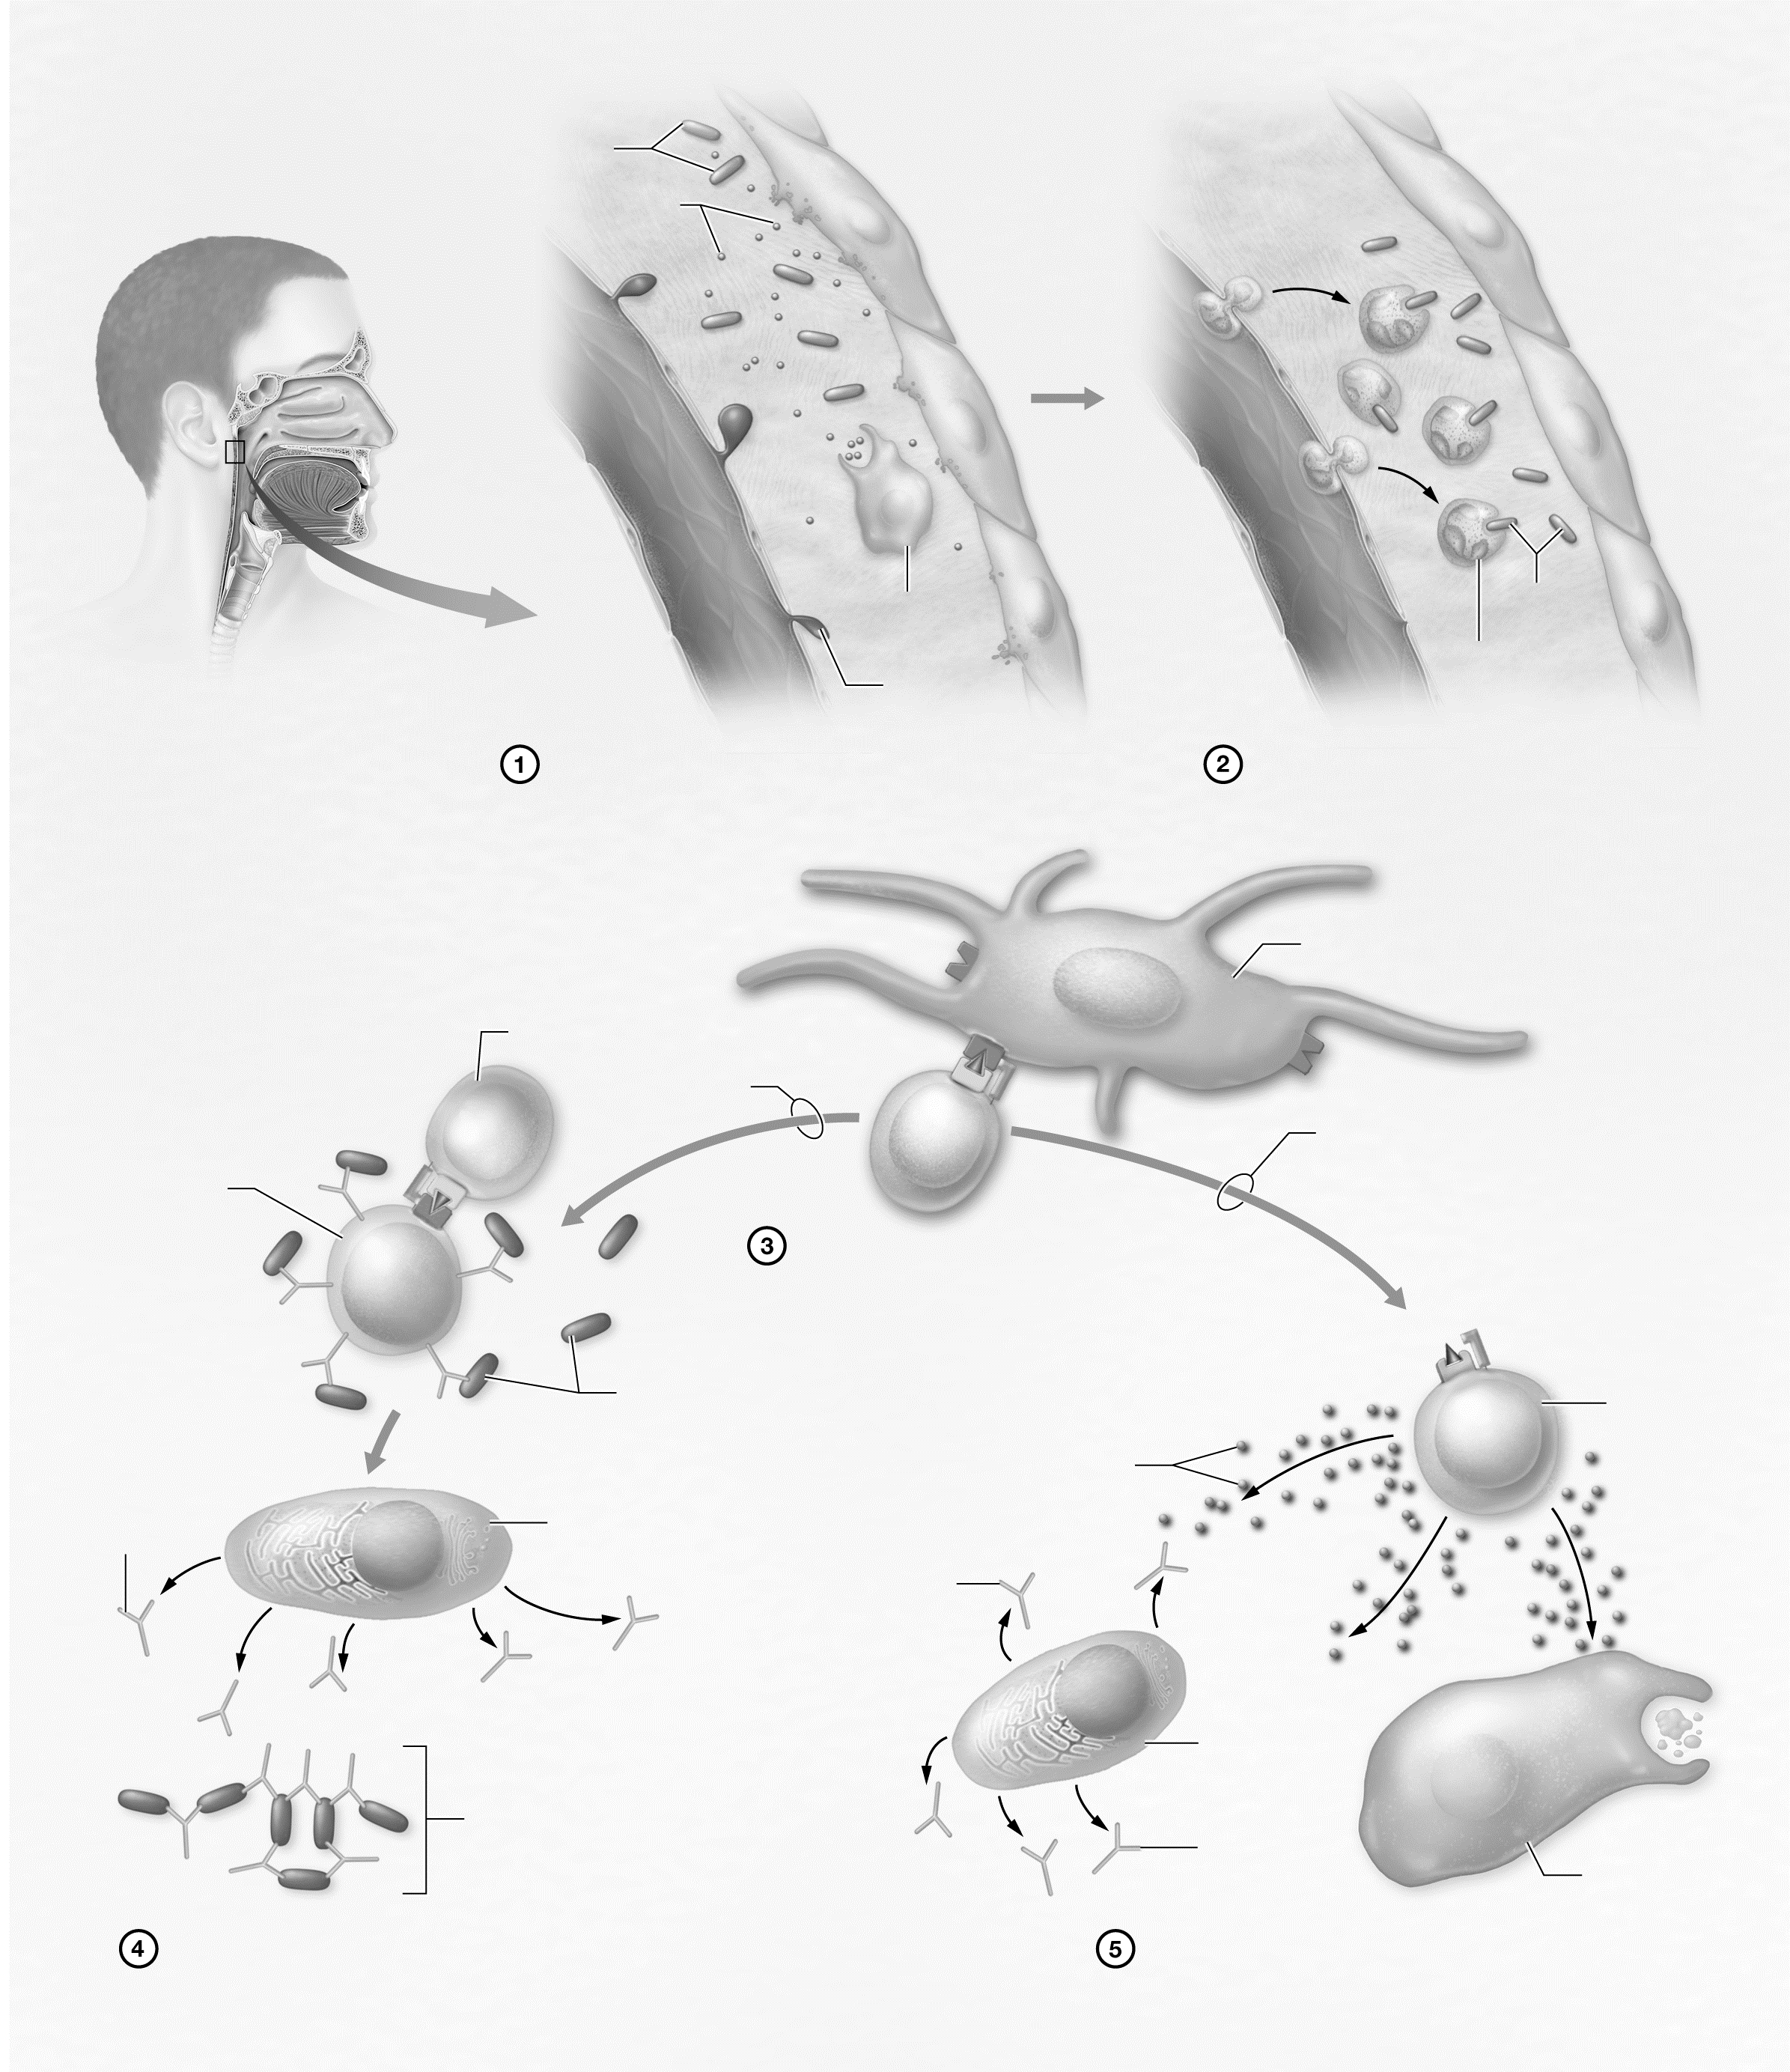

Figure 20.9 Immune response to a bacterial infection.
Key Concept: How does the response to a bacterial infection differ from the response to a viral infection?

Describe It: Immune Response to Cancer
Describe the sequence of events by which the immune system responds to cancer cells in Figure 20.10. In addition, label and color-code each component of the process.
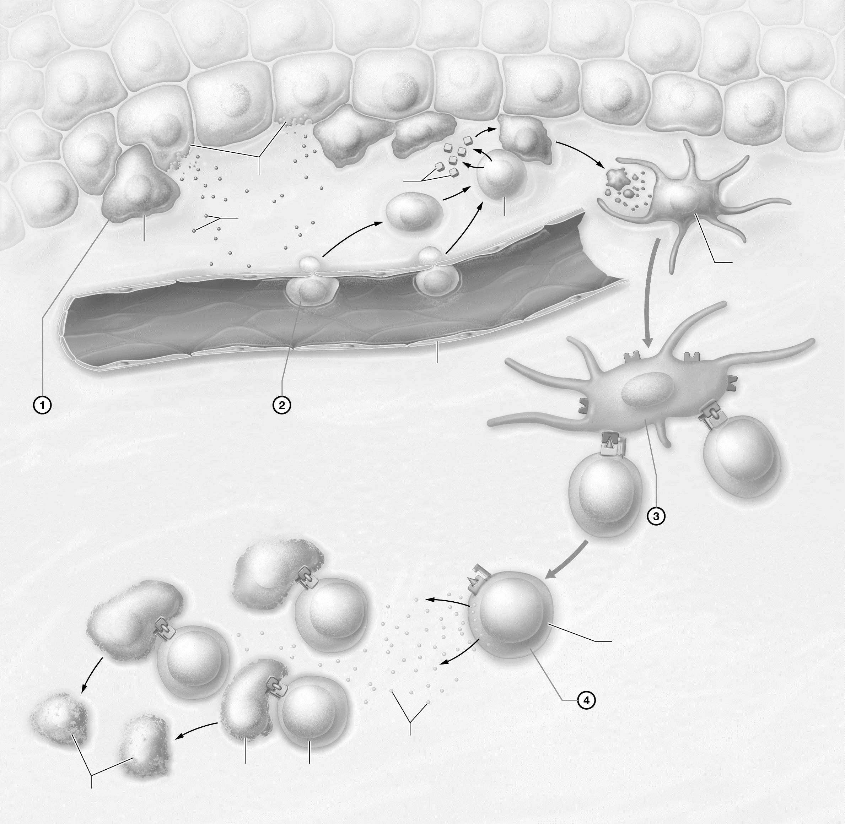

Figure 20.10 Immune response to cancer cells.
Key Concept: How does the response to cancer cells differ from the responses to most infectious pathogens?

Module 20.7: Disorders of the Immune System
Module 20.7 in your text discusses what happens when parts of the immune system are either overactive or underactive. By the end of the module, you should be able to do the following:
1. Describe the characteristics of the types of hypersensitivity disorders.
2. Describe the common immunodeficiency disorders.
3. Explain why HIV targets certain cell types, and describe the effects this virus has on the immune system.
4. Describe the characteristics of common autoimmune disorders.
Build Your Own Glossary
Following is a table listing key terms from Module 20.7. Before you read the module, use the glossary at the back of your book or look through the module to define the following terms.
Key Terms for Module 20.7
Term | Definition
Hypersensitivity disorder
Anaphylactic shock
Immunodeficiency disorder
Acquired immunodeficiency disorder
Autoimmune disorder
Outline It: Note Taking
Outline Module 20.7 using the note-taking technique you practiced in the introductory chapter (see Chapter 1). (The template is available in the study area of Mastering A&P.)
Key Concept: Why is a type I hypersensitivity reaction much more severe upon a second exposure to the allergen?

Build Your Own Summary Table: Immune Disorders
As you read Module 20.7, build your own summary table about the different types of immune disorders by filling in the information in the following table.
Types of Immune Disorders
Type of Immune Disorder | Description/Causes | Example
Hypersensitivity Disorders
Type I hypersensitivity
Type II hypersensitivity
Type III hypersensitivity
Type IV hypersensitivity
Immunodeficiency Disorders
Primary immunodeficiency disorders
Secondary immunodeficiency disorders
Autoimmune Disorders
Autoimmune disorders

Key Concept: Why does the loss of functional T_{H} cells in HIV/AIDS cause problems for the entire immune system?


What Do You Know Now?
Let’s now revisit the questions you answered at the beginning of this chapter. How have your answers changed now that you’ve worked through the material?
• Why does a healthcare provider palpate (feel) your neck when you are sick?

• What causes flu-like symptoms when we get sick?

• What is the purpose of a fever?

Next Steps
You’ve just actively read your chapter, so now it’s time to start your Bring It Back practice sessions. What types of Bring It Back practice will you use to study lymphatics and immunity?
__________________________________________________________________________________________
__________________________________________________________________________________________
This is a long chapter with a lot of details. How will you adjust your Bring It Back practice to account for the amount of details?
__________________________________________________________________________________________
__________________________________________________________________________________________
If you recently had your first exam, how do you feel about your performance? How will you adjust your studying for future exams?
________________________________________________________________________________________________
________________________________________________________________________________

We’ll see you in the next chapter!

