21 | The Respiratory System
This chapter discusses the respiratory system. We begin by taking a tour of its organs and then explore its functions in greater detail. The chapter concludes with the two types of diseases that affect the respiratory system and their effects on homeostasis.
What Do You Think You Already Know?
Try to answer the following questions before proceeding to the next section. If you’re unsure of the correct answers, give it your best attempt based on previous courses, previous chapters, or just your general knowledge.
• What is/are the main function(s) of the respiratory system?

• How do we breathe?

• Why do we inhale oxygen and exhale carbon dioxide?

Module 21.1: Overview of the Respiratory System
This module introduces the basic structures of the respiratory system and its many roles in maintaining homeostasis. By the end of the module, you should be able to do the following:
1. Describe and distinguish between the upper and lower respiratory tracts.
2. Describe and distinguish between the conducting and respiratory zones of the respiratory tract.
3. Describe the major functions of the respiratory system.
4. Define and describe the four respiratory processes—pulmonary ventilation, pulmonary gas exchange, gas transport, and tissue gas exchange.

Build Your Own Glossary
Following is a table listing key terms from Module 21.1. Before you read the module, use the glossary at the back of your book or look through the module to define the following terms.
Key Terms for Module 21.1
Term | Definition
Respiratory tract
Conducting zone
Respiratory zone
Respiration
Outline It: Note Taking
Outline Module 21.1 using the note-taking technique you practiced in the introductory chapter (see Chapter 1). (The template is available in the study area of Mastering A&P.)
Identify It: Structures of the Respiratory System
Identify and color-code the structures of the respiratory system shown in Figure 21.1. In addition, identify each part of the respiratory tract as belonging to the conducting zone or respiratory zone.
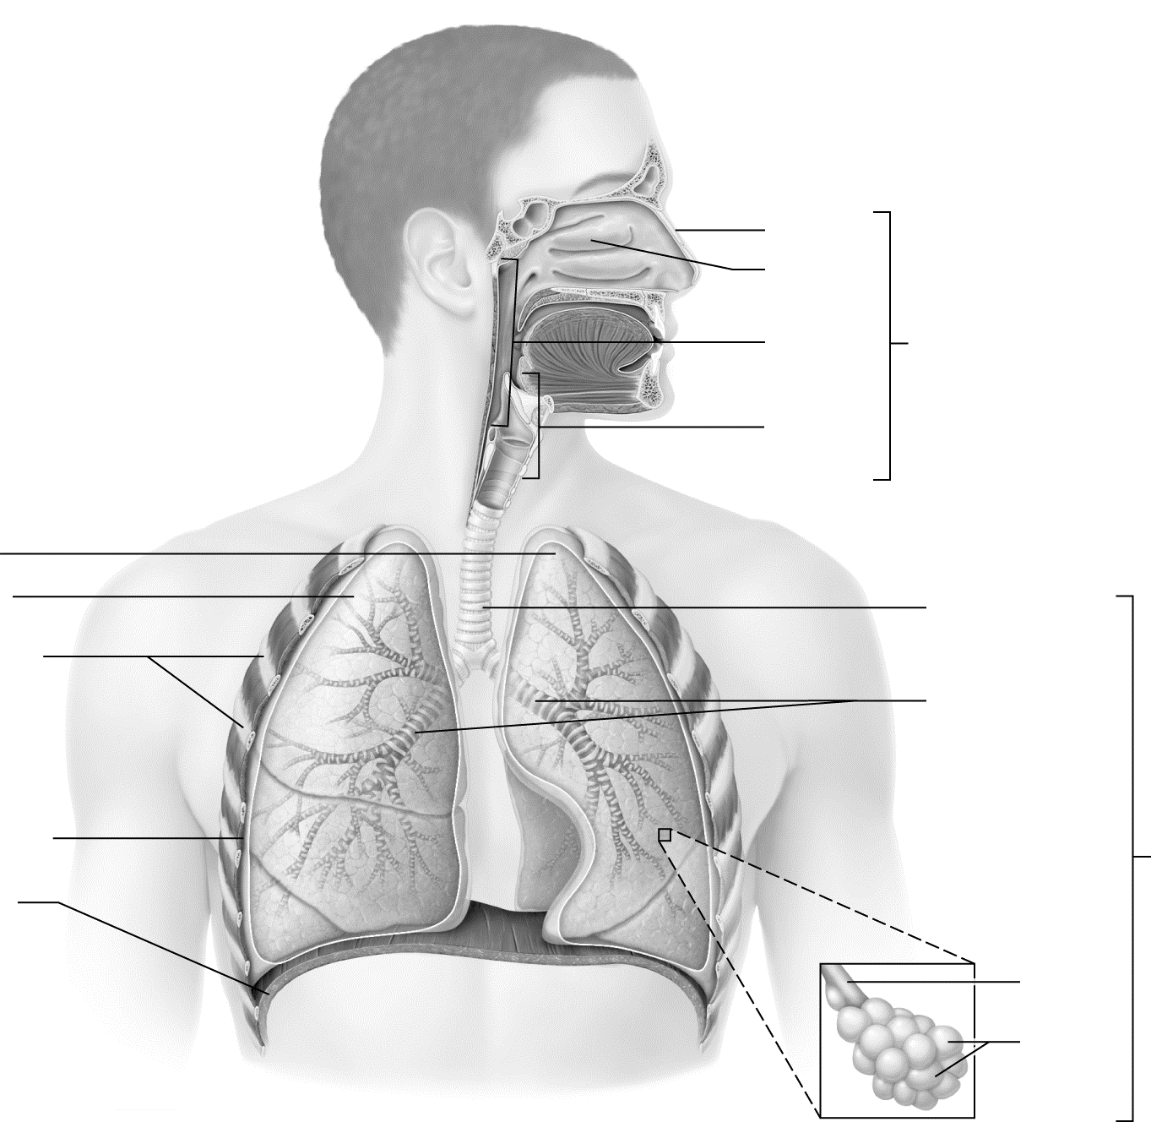

Figure 21.1 Structures of the respiratory system.
Key Concept: What is respiration? Which processes make up respiration?

Key Concept: What are the other functions of the respiratory system, and how do they help maintain homeostasis?

Module 21.2: Anatomy of the Respiratory System
In this module, we explore the organs of the respiratory system and follow the pathway that air takes through the group of structures collectively called the respiratory tract. When you finish this module, you should be able to do the following:
1. Trace the pathway through which air passes during inspiration.
2. Describe the gross anatomical features and function of each region of the respiratory tract, the pleural and thoracic cavities, and the pulmonary blood vessels and nerves.
3. Describe the histology of the different regions of the respiratory tract, the types of cells present in alveoli, and the structure of the respiratory membrane.
4. Explain how the changes in epithelial and connective tissue in air passageways relate to their function.
5. Describe the structure of the lungs and pleural cavities.
Build Your Own Glossary
Following is a table listing key terms from Module 21.2. Before you read the module, use the glossary at the back of your book or look through the module to define the following terms.
Key Terms for Module 21.2
Term | Definition
Nasal cavity
Paranasal sinuses
Respiratory mucosa
Pharynx
Larynx
Epiglottis
Vocal folds
Trachea
Bronchial tree
Alveoli
Respiratory membrane
Lung
Pleural cavity
Outline It: Note Taking
Outline Module 21.2 using the note-taking technique you practiced in the introductory chapter (see Chapter 1). (The template is available in the study area of Mastering A&P.)

Identify It: The Nose and Nasal Cavity
Identify and color-code the structures of the nose and nasal cavity in Figure 21.2.
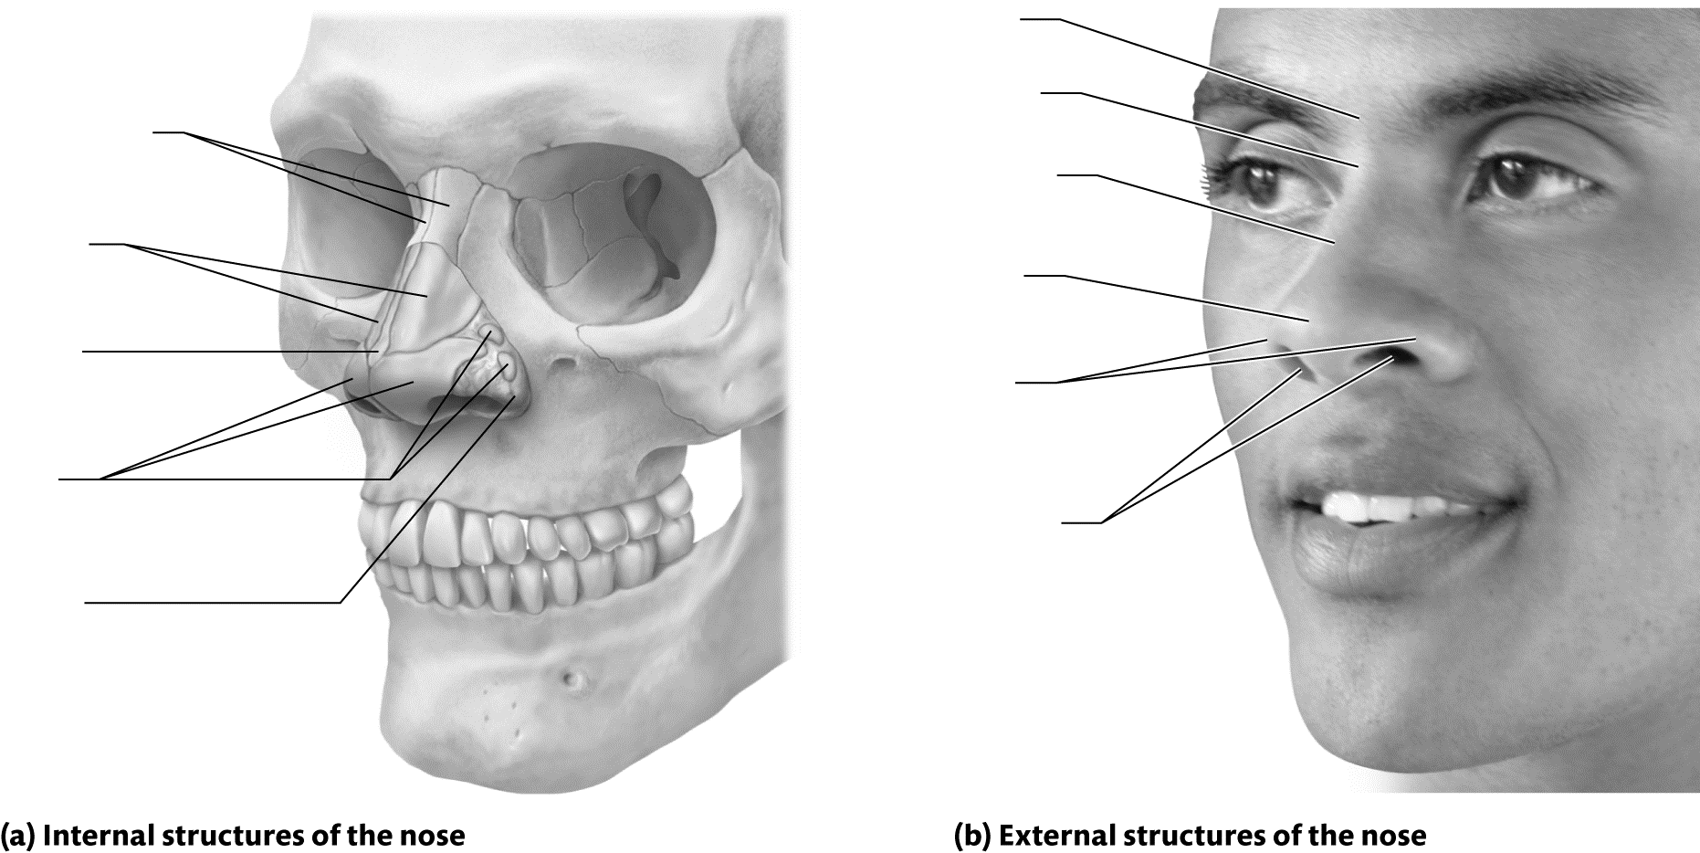

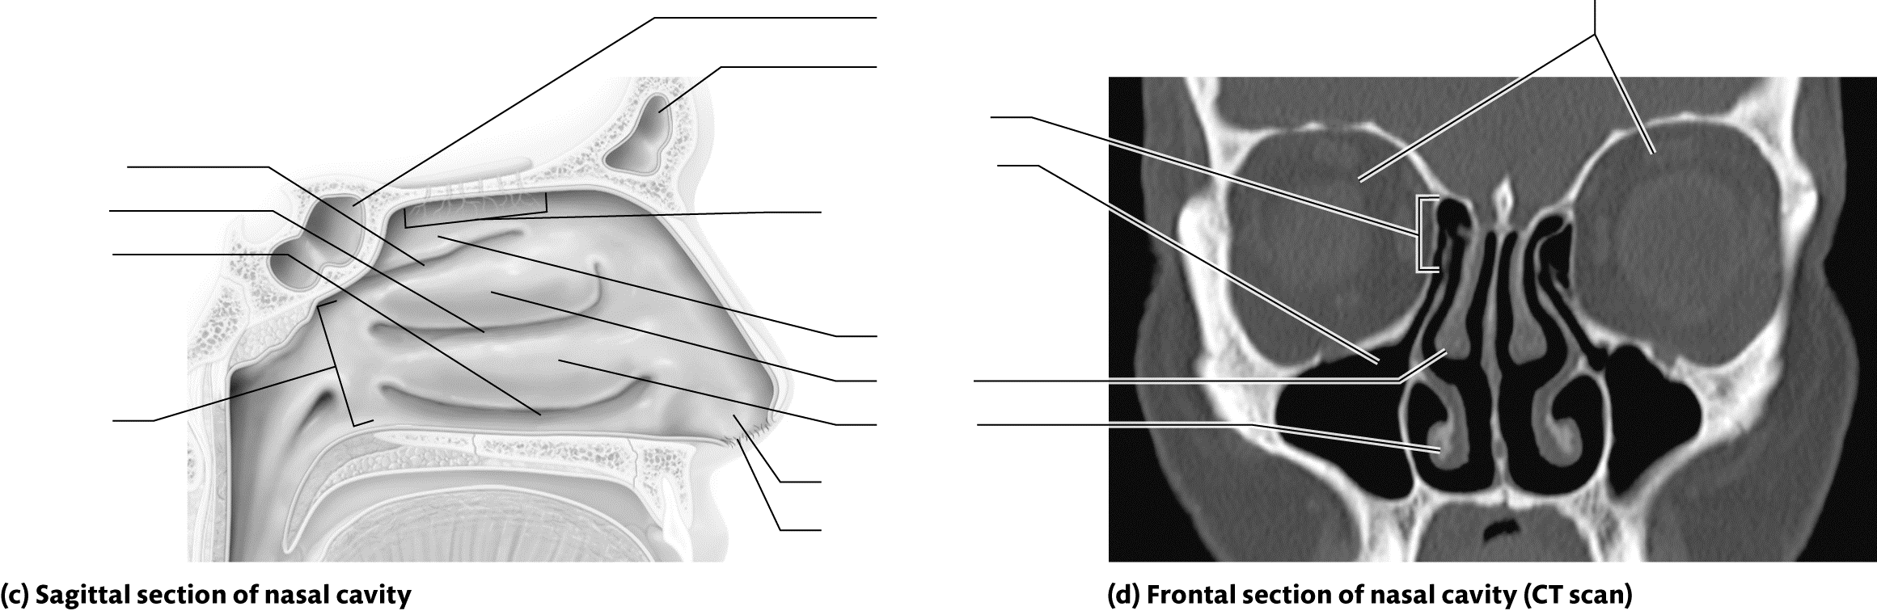
Figure 21.2 Structures of the nose and nasal cavity.
Key Concept: Where are the paranasal sinuses located? What are their functions? Could they perform these functions if they were lined with stratified squamous epithelium instead of respiratory epithelium?

Key Concept: What delineates the three different regions of the pharynx? How do they differ, structurally and functionally?

Identify It: The Larynx
Identify and color-code the structures of the larynx in Figure 21.3.
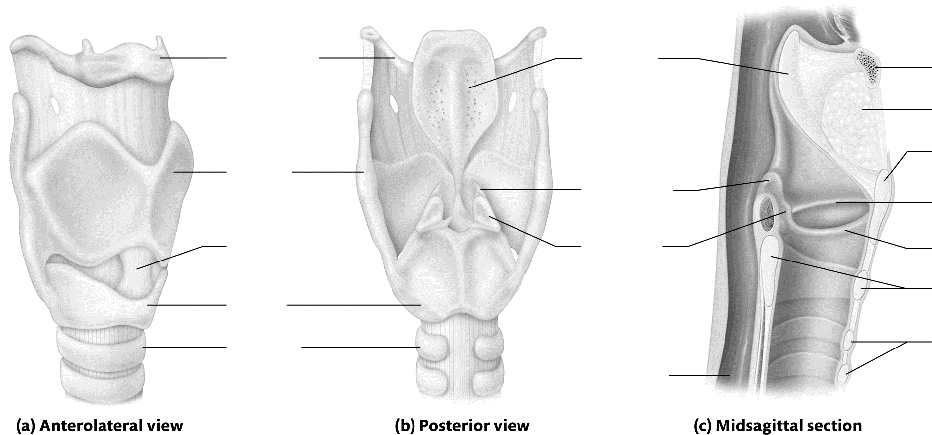

Figure 21.3 Anatomy of the larynx.
Key Concept: How does the change in tension on the vocal cords and the size of the glottis affect the loudness and pitch of the sound produced?

Identify It: The Trachea and Bronchial Tree
Identify and color-code the structures of the trachea and bronchial tree in Figure 21.4.
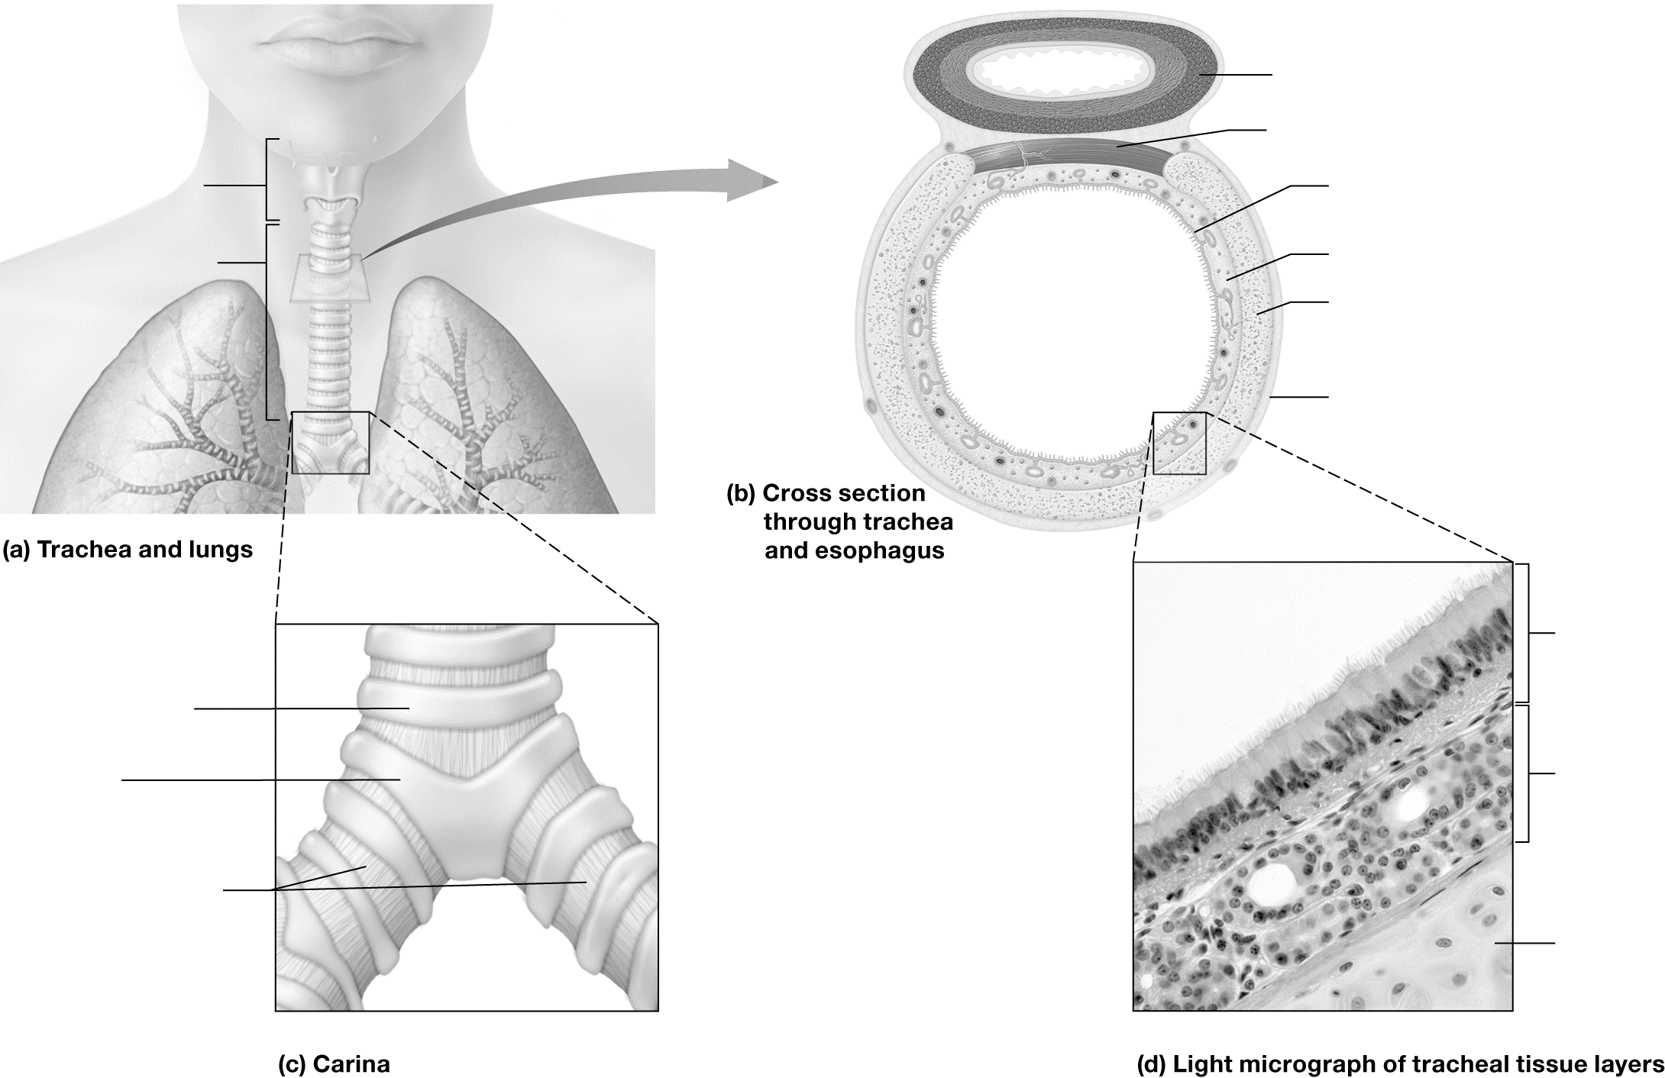
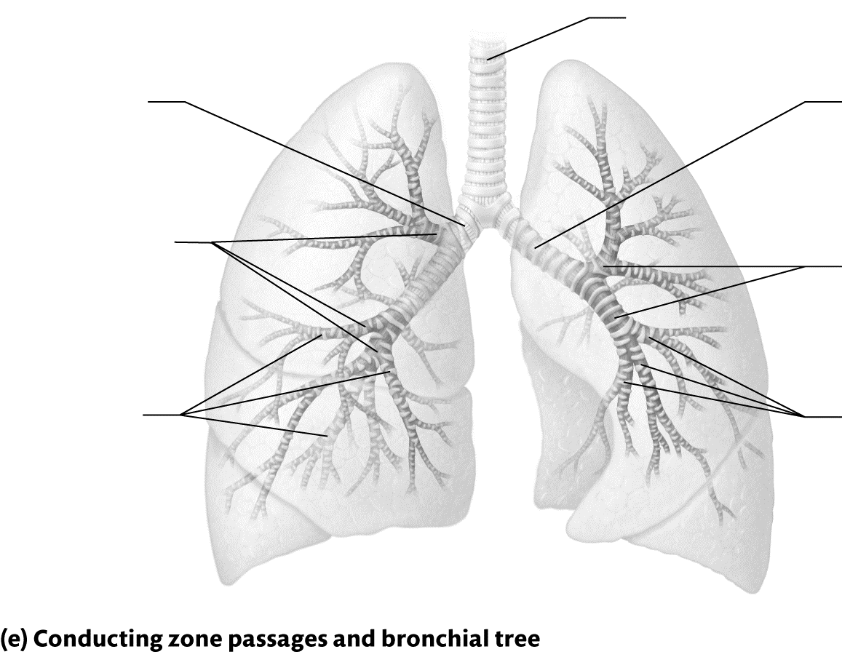
Figure 21.4 The trachea and bronchial tree.

Identify It: Anatomy of the Respiratory Zone
Identify and color-code the structures of the respiratory zone in Figure 21.5.
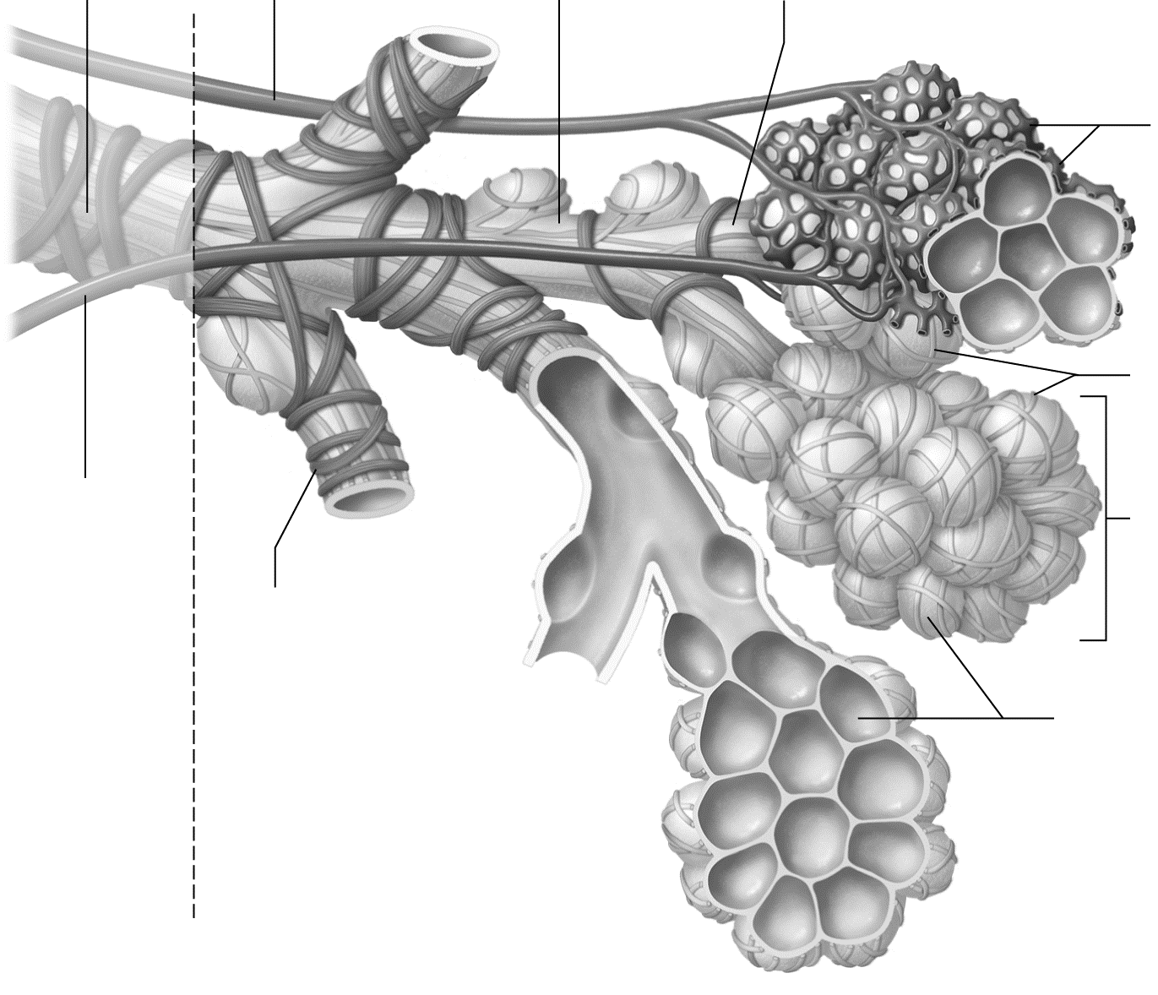
Figure 21.5 Anatomy of the respiratory zone.
Trace It: Pathway of Air Flow through the Respiratory System
Trace the pathway of air as it flows from the nares through the bronchial tree to the alveoli.
Start: Nares →

→ End: Alveoli
Identify It: The Respiratory Membrane
Identify and color-code the structures of the alveoli and respiratory membrane in Figure 21.6.
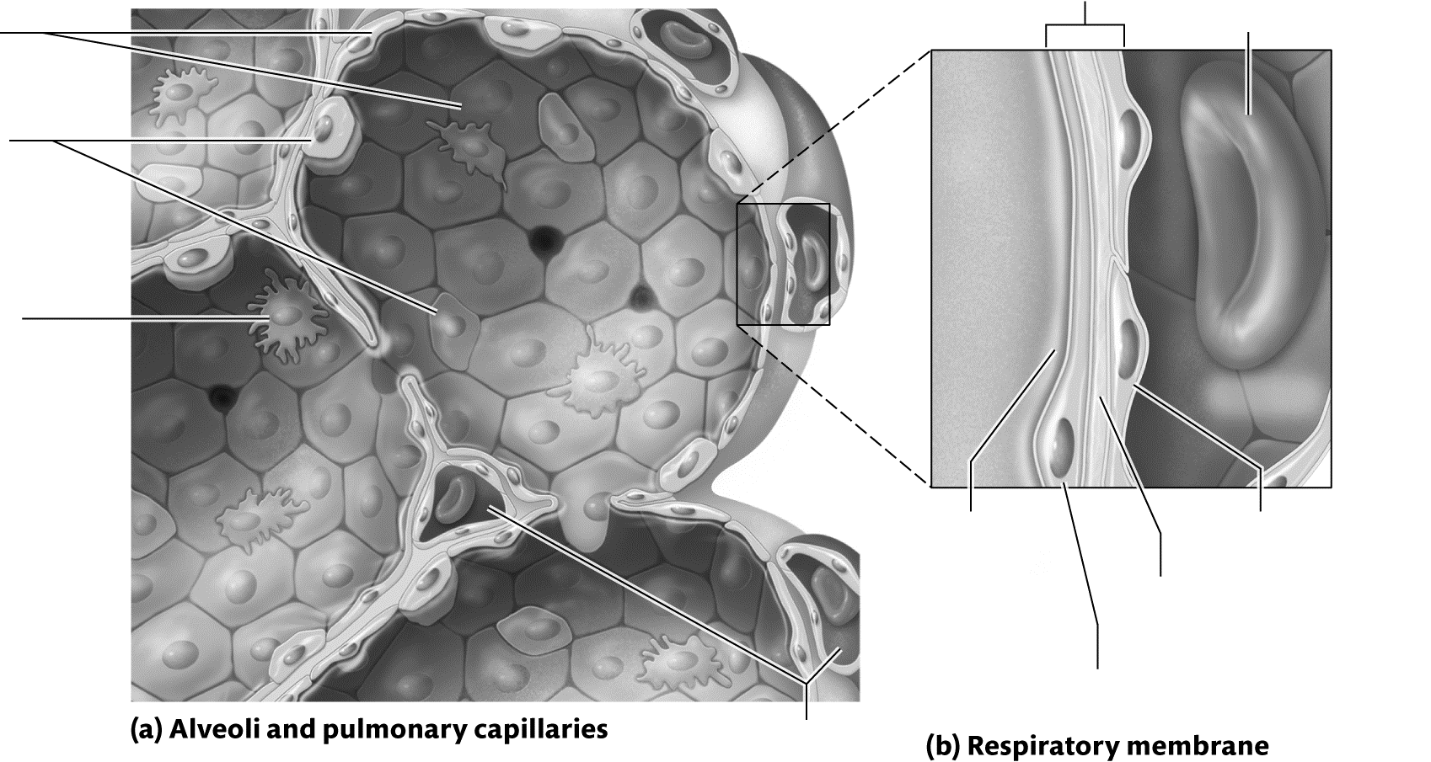
Figure 21.6 The respiratory membrane.
Key Concept: Which structures make up the respiratory membrane? Would the function of the membrane change if it were to become thicker? How?

Identify It: The Lungs and Pleural Cavities
Identify and color-code the structures of the lungs and pleural cavities in Figure 21.7.
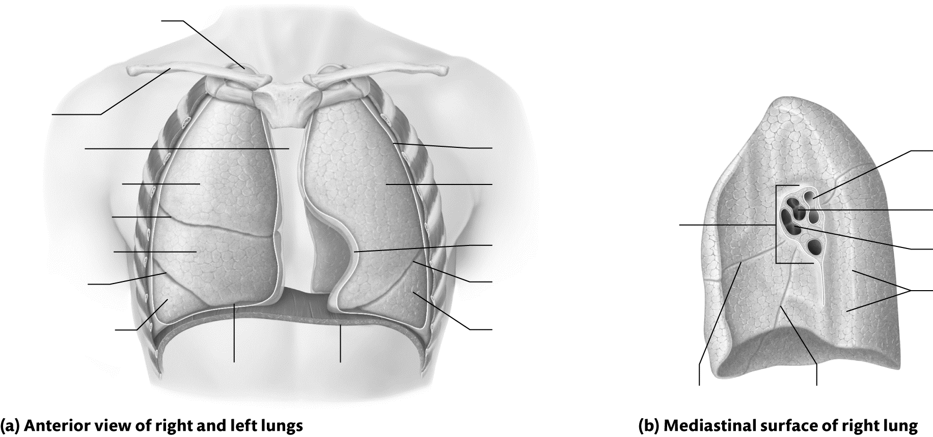
Figure 21.7 The lungs and pleural cavities.

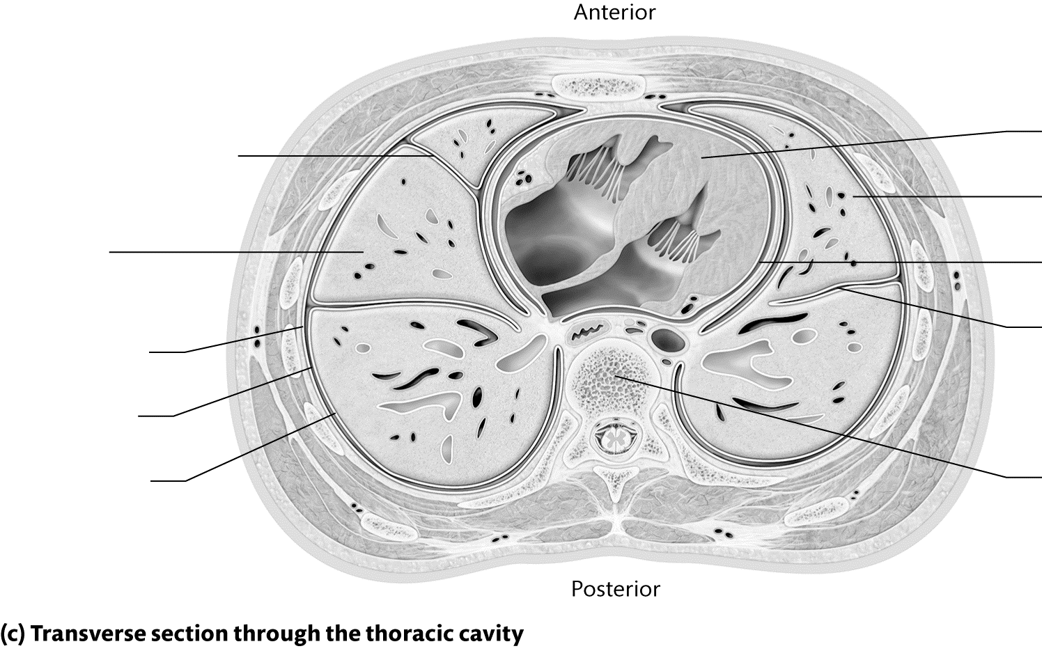

Figure 21.7 (continued)

Module 21.3: Pulmonary Ventilation
This module begins our venture into respiratory physiology. In it, we will discuss the mechanics of breathing: how we actually get air into and out of our lungs. When you have completed the module, you should be able to do the following:
1. Describe how pressure and volume are related, and explain how this relationship applies to pulmonary ventilation.
2. Explain how the inspiratory muscles, accessory muscles of inspiration, and accessory muscles of expiration change the volume of the thoracic cavity.
3. Explain how the values for atmospheric pressure, intrapulmonary pressure, and intrapleural pressure change with inspiration and expiration.
4. Explain how each of the following factors affects pulmonary ventilation: airway resistance, pulmonary compliance, and alveolar surface tension.
5. Describe and identify the values for the respiratory volumes and the respiratory capacities.
Build Your Own Glossary
Following is a table listing key terms from Module 21.3. Before you read the module, use the glossary at the back of your book or look through the module to define the following terms.
Key Terms for Module 21.3
Term | Definition
Pulmonary ventilation
Inspiration
Expiration
Pressure gradient
Boyle’s law
Inspiratory muscles
Atmospheric pressure
Intrapulmonary pressure
Intrapleural pressure
Airway resistance
Alveolar surface tension
Pulmonary compliance
Spirometer
Pulmonary capacities

Outline It: Note Taking
Outline Module 21.3 using the note-taking technique you practiced in the introductory chapter (see Chapter 1). (The template is available in the study area of Mastering A&P.)
Key Concept: What is a pressure gradient? How do pressure gradients drive the movement of gases into and out of the lungs?

Complete It: Overview of Pulmonary Ventilation
Fill in the blanks to complete the following paragraphs that describe the basic principles of pulmonary ventilation.
The main inspiratory muscle is the ________________. It creates a pressure gradient when it contracts by ________________ the volume of the lungs, which ________________ the pressure in the lungs. When the pressure in the lungs, or the ________________ ________________, falls below ________________ ________________, air enters the lungs via ________________. During forced inspiration, other muscles called ________________ ________________ assist in the process.
The process of expiration is largely ________________ due to the ________________ ________________ ________________. This causes the volume of the lungs to ________________, which ________________ intrapulmonary pressure. When intrapulmonary pressure is ________________ ________________ atmospheric pressure, ________________ occurs.
Key Concept: Why is intrapleural pressure slightly lower than intrapulmonary pressure? What happens if it rises above intrapulmonary pressure?

Predict It: Factors That Influence Pulmonary Ventilation
Predict whether the efficiency of pulmonary ventilation will increase or decrease given each of the following conditions. Justify each of your responses.
• A person inhales methacholine, which causes bronchoconstriction.

• An infant is born premature and does not produce surfactant.

• The premature infant is given inhalable surfactant as a treatment.

• A person develops emphysema, causing the destruction of alveolar walls.

• A person is administered epinephrine, which causes bronchodilation.

• A chest wall deformity prevents normal expansion of the lungs.

Key Concept: What are the three physical factors that influence ventilation? How does each influence the efficiency of ventilation?

Build Your Own Summary Table: Pulmonary Volumes and Capacities
As you read Module 21.3, build your own summary table about the pulmonary volumes and capacities by filling in the information in the following table. When you have finished, check your answers with text Table 21.4 on page 827.
Pulmonary Volumes and Capacities
Measurement | Average Value (Female/Male) | Definition
Pulmonary Volumes
Tidal volume
Inspiratory reserve volume
Expiratory reserve volume
Residual volume
Pulmonary Capacities
Inspiratory capacity
Functional residual capacity
Vital capacity
Total lung capacity
Module 21.4: Gas Exchange
This module examines how gases diffuse across the respiratory membrane and the walls of the systemic capillaries. When you have finished the module, you should be able to do the following:
1. Describe the relationship of Dalton’s law and Henry’s law to pulmonary and tissue gas exchange and to the amounts of oxygen and carbon dioxide dissolved in plasma.
2. Describe oxygen and carbon dioxide pressure gradients and net gas movements in pulmonary and tissue gas exchange.
3. Explain how oxygen and carbon dioxide movements are affected by changes in partial pressure gradients.
4. Describe the mechanisms of ventilation-perfusion matching.
5. Explain the factors that maintain oxygen and carbon dioxide gradients between blood and tissue cells.
Build Your Own Glossary
Following is a table listing key terms from Module 21.4. Before you read the module, use the glossary at the back of your book or look through the module to define the following terms.
Key Terms for Module 21.4
Term | Definition
Pulmonary gas exchange
Tissue gas exchange
Dalton’s law of partial pressures
Henry’s law
Ventilation-perfusion matching

Outline It: Note Taking
Outline Module 21.4 using the note-taking technique you practiced in the introductory chapter (see Chapter 1). (The template is available in the study area of Mastering A&P.)

Complete It: The Behavior of Gases
Fill in the blanks to complete the following paragraphs that describe the behavior of gases and relevant gas laws.
Each gas in a mixture exerts its own pressure on the mixture, which is known as ________________ ________________ ________________ ________________. The partial pressures of gases in a mixture determine whether the gases will move by ________________—gases move from an area of ________________ pressure to an area of ________________ pressure, following a pressure gradient. A second relevant gas law is Henry’s law, which states that a gas’s ability to dissolve in a liquid is proportional to its ________________ ________________ and its ________________ in the liquid. Henry’s law helps to explain why we find very little ________________ ________________ in plasma in spite of its high partial pressure in the air we breathe.
During pulmonary gas exchange, oxygen moves from an area of ________________ partial pressure in the ________________ to an area of ________________ partial pressure in the ________________ ________________. Carbon dioxide moves in the opposite direction, going from an area of ________________ partial pressure in the ________________ ________________ to an area of ________________ partial pressure in the ________________. In the tissues, the opposite occurs, with oxygen moving from a high partial pressure in the ________________ _______________ to an area of low partial pressure in the ________________, and carbon dioxide moving from an area of high partial pressure in the ________________ to an area of low partial pressure in the ________________ ________________.
Key Concept: In which direction would oxygen diffuse if its partial pressure in the blood were 40 mm Hg and its partial pressure in the alveoli were 35 mm Hg? How would this affect homeostasis overall?

Practice It
For each of the following scenarios, state whether pulmonary and/or tissue gas exchange will increase or decrease.
1. Emphysema causes destruction of alveolar walls. _______________
2. Long-standing pulmonary hypertension thickens the pulmonary capillary walls. _______________
3. Vasodilators increase the perfusion to a systemic capillary bed. _______________
4. A pulmonary embolus (clot) blocks blood flow to a certain part of the lung. _______________
5. A person inhales 100% oxygen. _______________
6. Systemic capillary beds are damaged by hyperglycemia due to unmanaged diabetes
mellitus. _______________
Module 21.5: Gas Transport through the Blood
Gases will not dissolve to a great extent in plasma, which means that our bodies must transport them in
other ways. This module explores these transport mechanisms and the significant ways in which gas transport contributes to the body’s general homeostasis. When you have finished the module, you should be able to do the following:
1. Describe the ways in which oxygen is transported in blood, including the reversible reaction for oxygen binding to hemoglobin.
2. Interpret the oxygen-hemoglobin dissociation curve, and describe the factors that affect the curve.
3. Describe the ways in which carbon dioxide is transported in blood, including the reversible reaction that converts carbon dioxide and water to carbonic acid.
4. Predict how changing the partial pressure of carbon dioxide will affect the pH of plasma.
5. Describe the conditions hyperventilation and hypoventilation.
Build Your Own Glossary
Following is a table listing key terms from Module 21.5. Before you read the module, use the glossary at the back of your book or look through the module to define the following terms.
Key Terms for Module 21.5
Term | Definition
Gas transport
Deoxyhemoglobin
Oxyhemoglobin
Percent saturation of hemoglobin
Oxygen-hemoglobin dissociation curve
Bohr effect
Bicarbonate ion
Carbonic anhydrase
Carbonic acid–bicarbonate buffer system
Hyperventilation
Hypoventilation
Outline It: Note Taking
Outline Module 21.5 using the note-taking technique you practiced in the introductory chapter (see Chapter 1). (The template is available in the study area of Mastering A&P.)
Key Concept: Why is most oxygen transported on hemoglobin?

Describe It: Hemoglobin Loading and Unloading
Describe, label, and color-code the overall process of hemoglobin loading and unloading in Figure 21.8. In addition, draw in the arrows to indicate the direction in which oxygen is diffusing in each part.
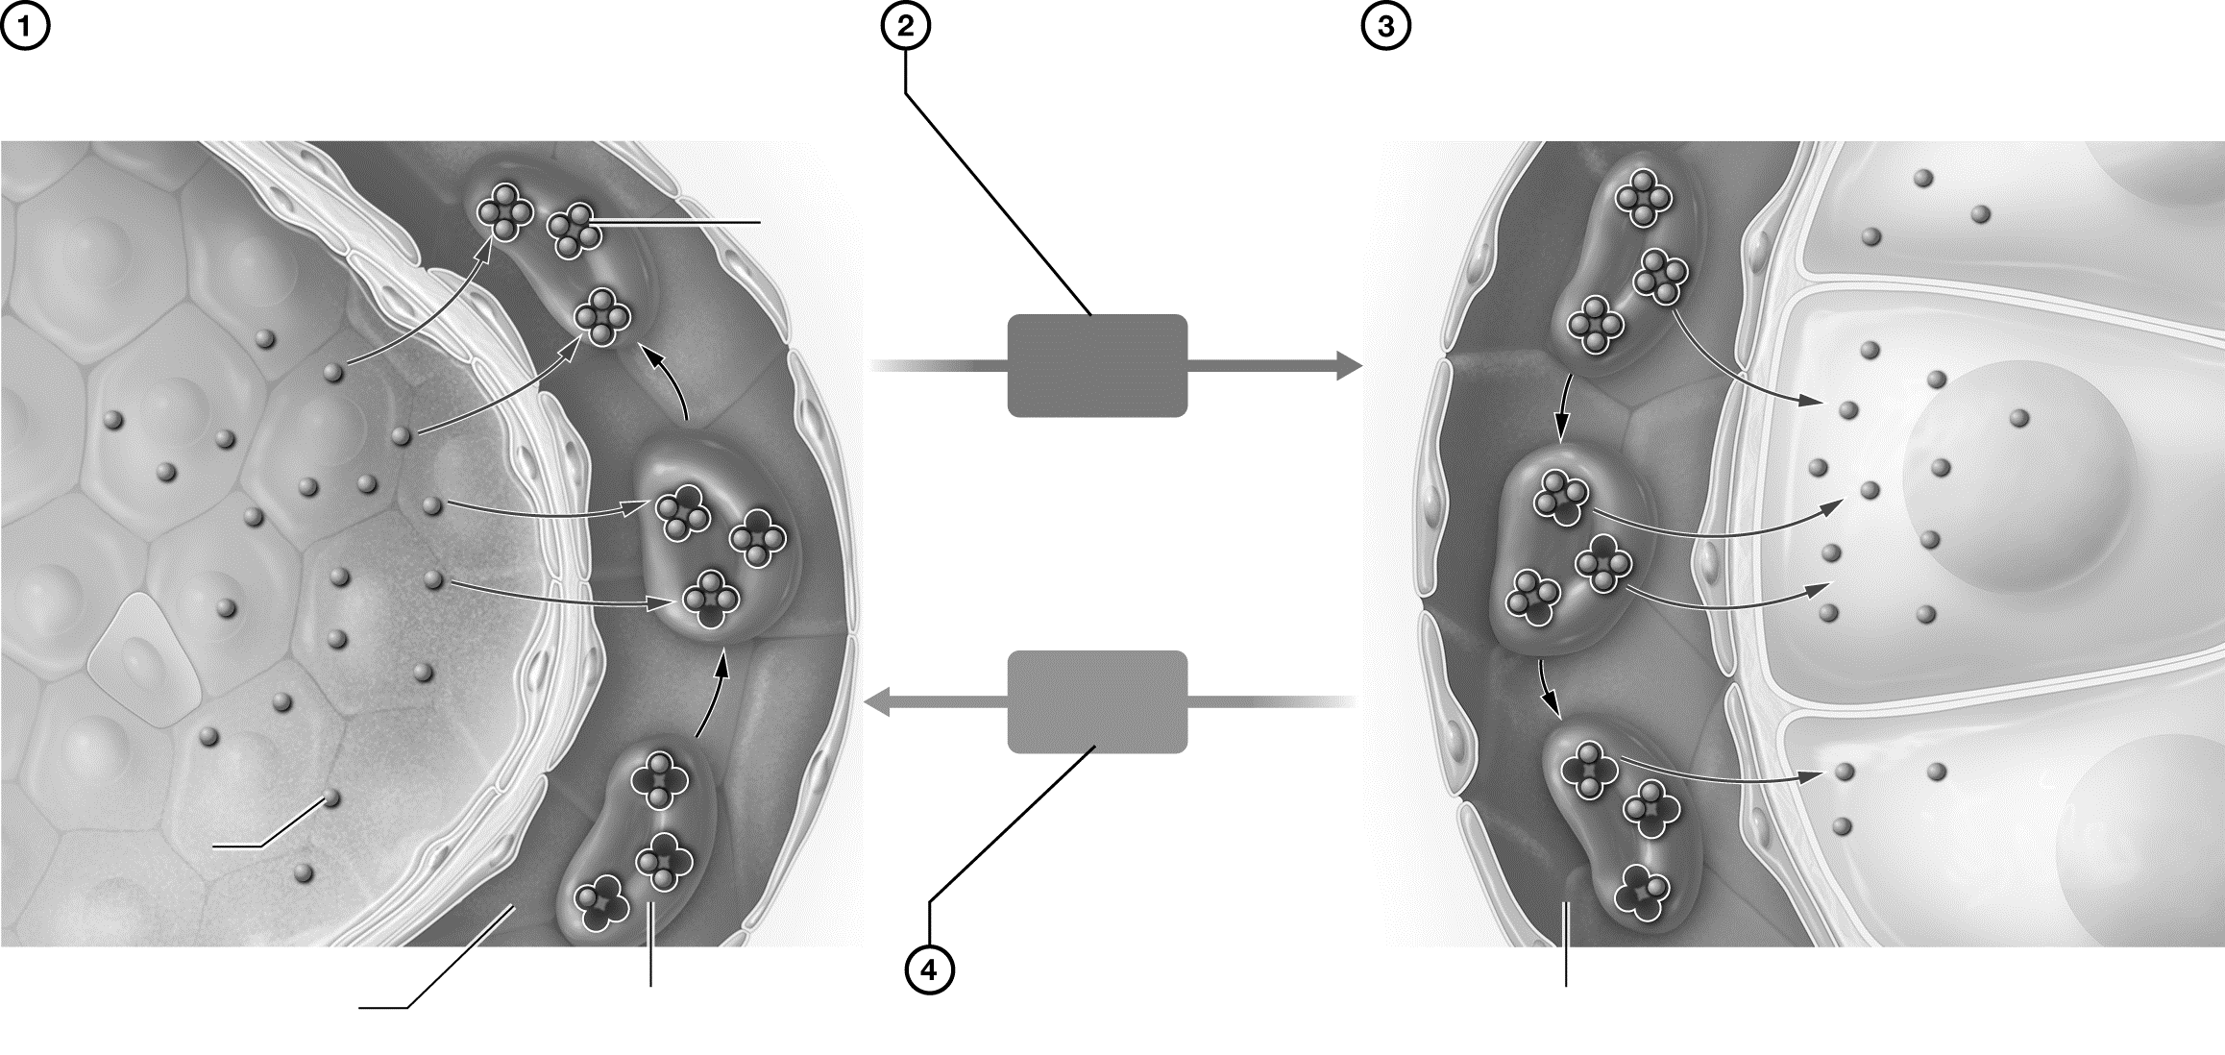

Figure 21.8 Hemoglobin loading and unloading.
Key Concept: How does the percent saturation of hemoglobin affect hemoglobin’s ability to unload oxygen? Why is this important to maintaining homeostasis?

Practice It
For each of the following scenarios, state whether the situation would cause more or less oxygen to be unloaded from Hb in the tissues.
1. pH increase ___________________________  2. Temperature decrease ___________________  3. Acidity increase ________________________  4. BPG concentration increase _______________  5. PCO2 increase ___________________________ | 6. PO2 increase ______________________________  7. PCO2 decrease _____________________________  8. PO2 decrease ______________________________  9. Temperature increase _______________________  10. Vigorous exercise __________________________
Describe It: Transport of Carbon Dioxide as Bicarbonate Ions
Describe, label, and color-code the overall process of carbon dioxide transport as bicarbonate ions in
Figure 21.9.
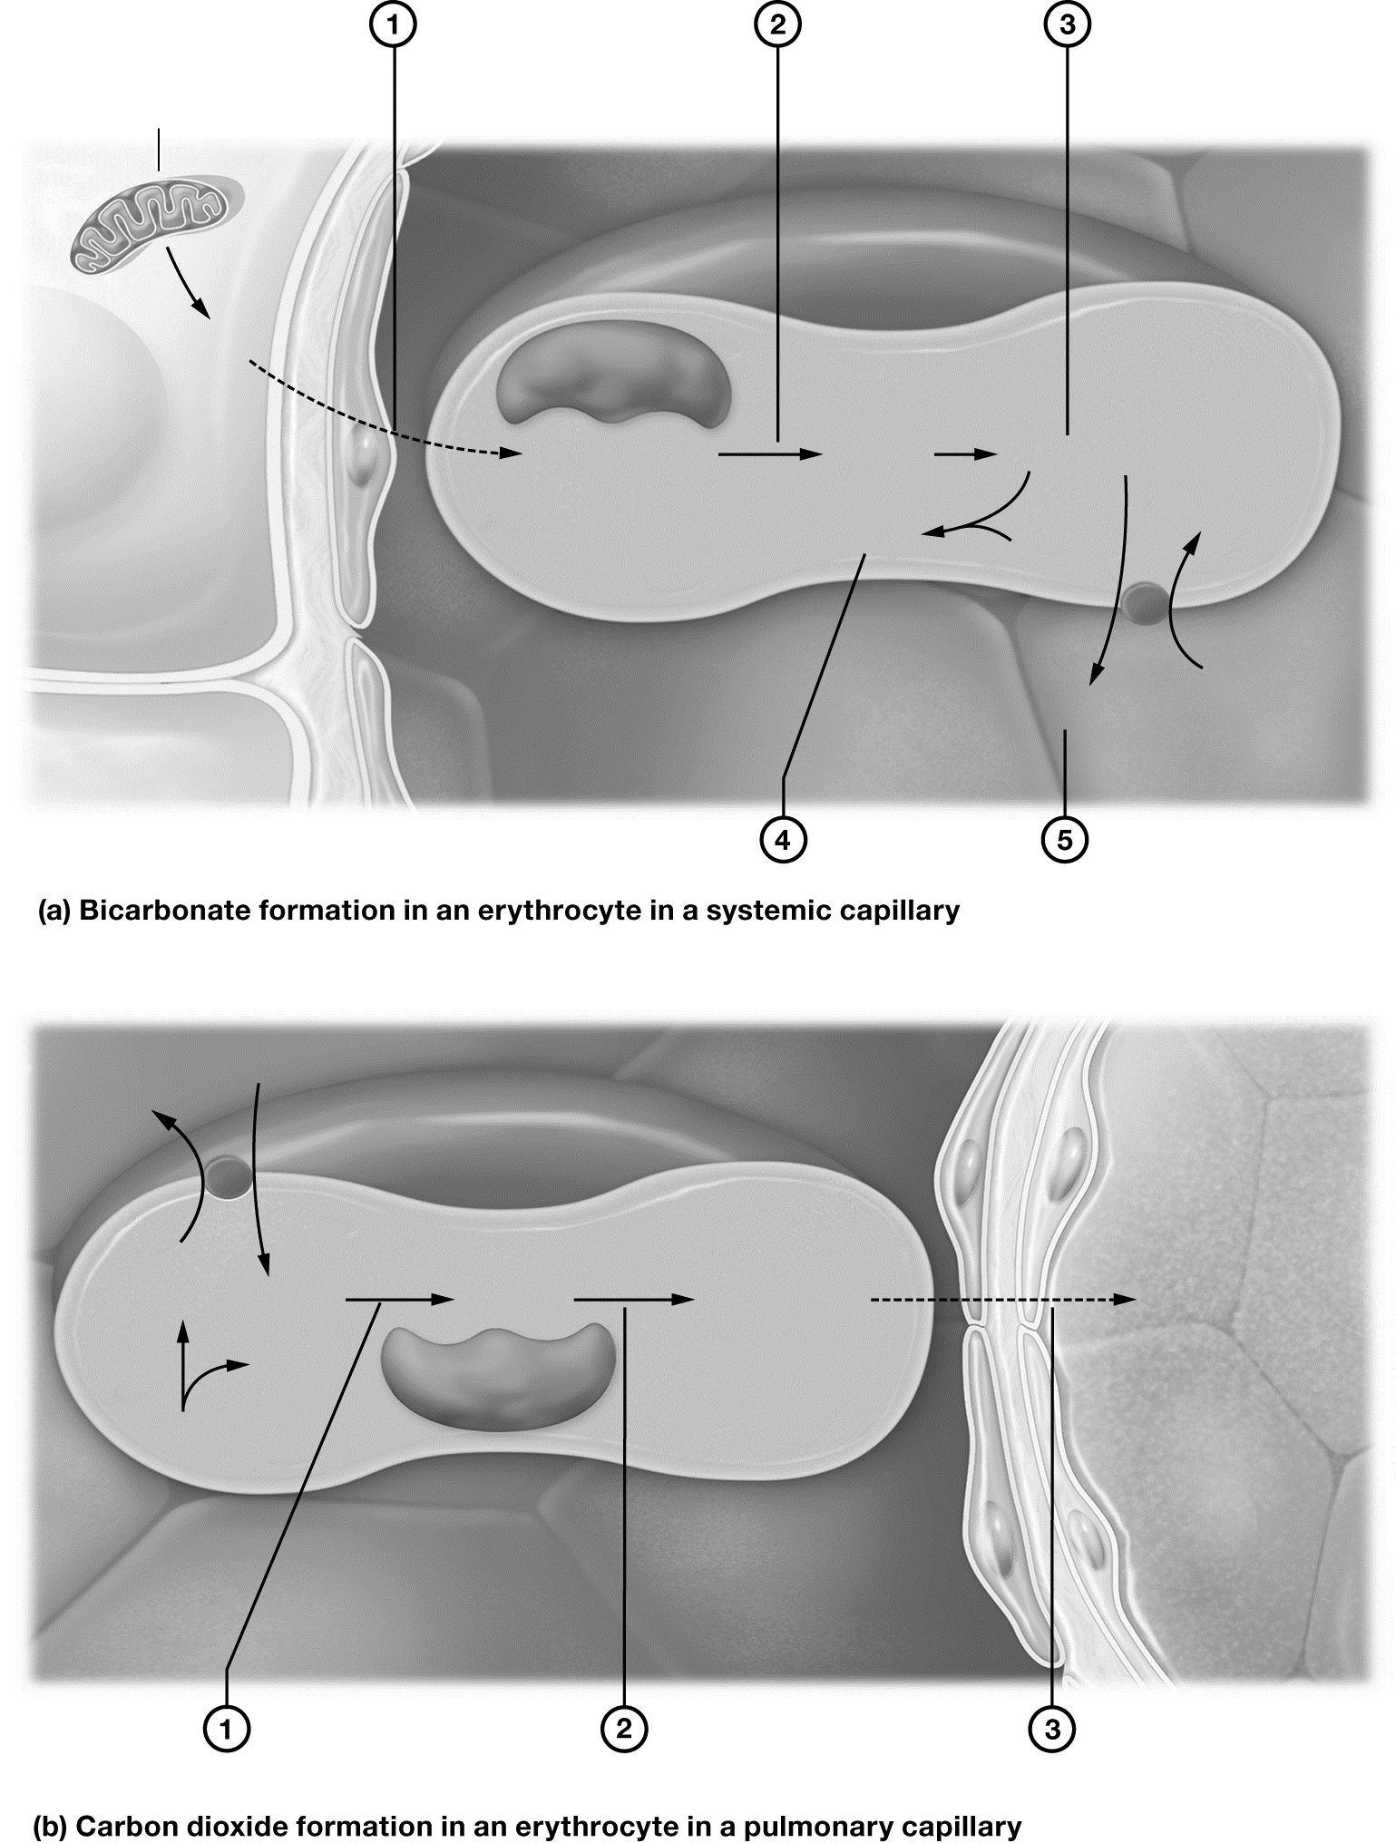

Figure 21.9 Transport of carbon dioxide as bicarbonate ions.

Trace It: Effect of Ventilation Changes on pH
In the following boxes, trace each step of the changes that take place according to the rate and depth of ventilation, along with the resulting pH change.
Hypoventilation | Hyperventilation
Rate/depth of breathing ____________ | Rate/depth of breathing ____________
P_{C}O2 in blood ____________ | P_{C}O2 in blood ____________
Carbonic acid concentration ____________ | Carbonic acid concentration ____________
Body fluid pH ____________ | Body fluid pH ____________
Key Concept: Why does the carbon dioxide level of the blood influence the pH of the blood and body fluids?

Module 21.6: Putting It All Together: The Big Picture of Respiration
Let’s now put all four processes of respiration together to see the big picture. When you have completed this module, you should be able to do the following:
1. Describe the overall big picture of the processes involved in respiration.

Describe It: The Big Picture of Respiration
Describe, label, and color-code the overall process of respiration in Figure 21.10. In addition, draw in the arrows to indicate the direction in which oxygen and carbon dioxide are moving in each step.
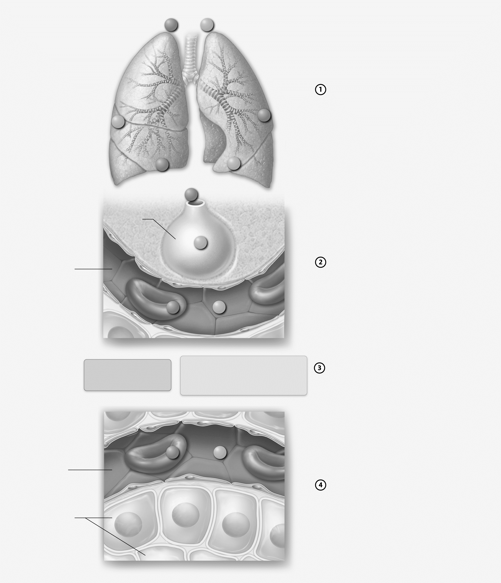

Figure 21.10 The big picture of respiration.


Mix It Up: Bring It Back by Describing the Big Picture of Pulmonary Ventilation
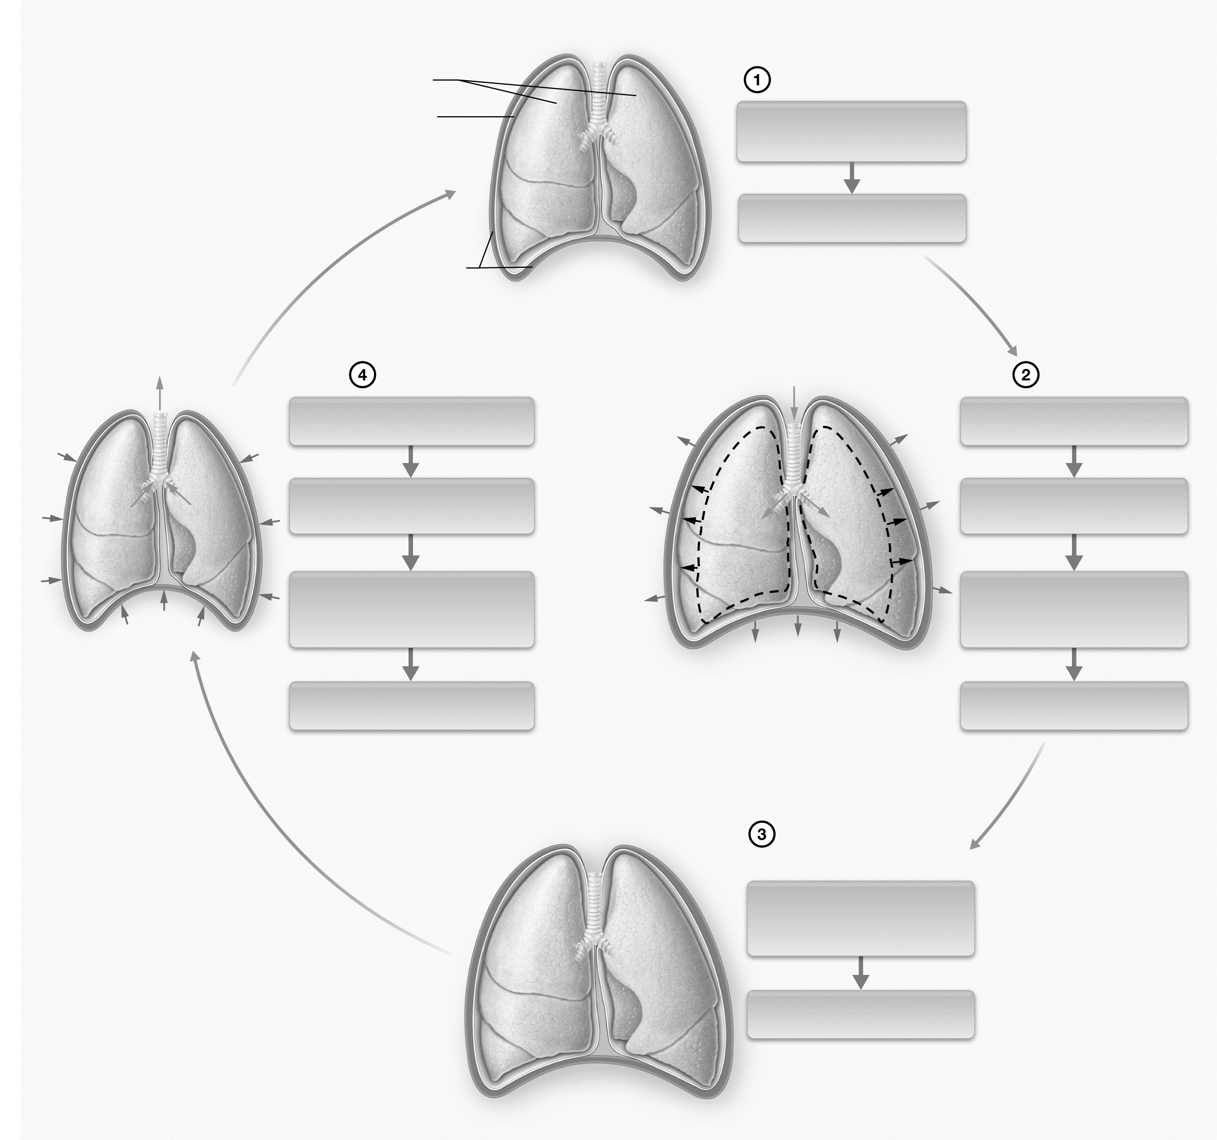
Let’s Mix It Up by describing the changes in lung volume and pressure during inspiration and expiration in Figure 21.11. Also, draw arrows to indicate muscle movement and the changes in lung volume.

Figure 21.11 The big picture of pulmonary ventilation.

Module 21.7: Neural Control of Ventilation
At this point in the chapter we have examined all four processes of gas exchange, but we still have one final but very important topic left to cover: What causes us to breathe in the first place? We explore the answer to this question in this module, after which you should be able to do the following:
1. Describe the locations and functions of the brainstem respiratory centers.
2. List and describe the major chemical and neural stimuli to the respiratory centers.
3. Compare and contrast the central and peripheral chemoreceptors.
Build Your Own Glossary
Following is a table listing key terms from Module 21.7. Before you read the module, use the glossary at the back of your book or look through the module to define the following terms.
Key Terms for Module 21.7
Term | Definition
Dyspnea
Eupnea
Respiratory rhythm generator
Ventral respiratory group
Dorsal respiratory group
Central chemoreceptors
Peripheral chemoreceptors

Outline It: Note Taking
Outline Module 21.7 using the note-taking technique you practiced in the introductory chapter (see Chapter 1). (The template is available in the study area of Mastering A&P.)
Identify It: Neural Control of Ventilation
Identify and color-code each structure involved in the neural control of ventilation in Figure 21.12. Then, list the main function(s) of each component.
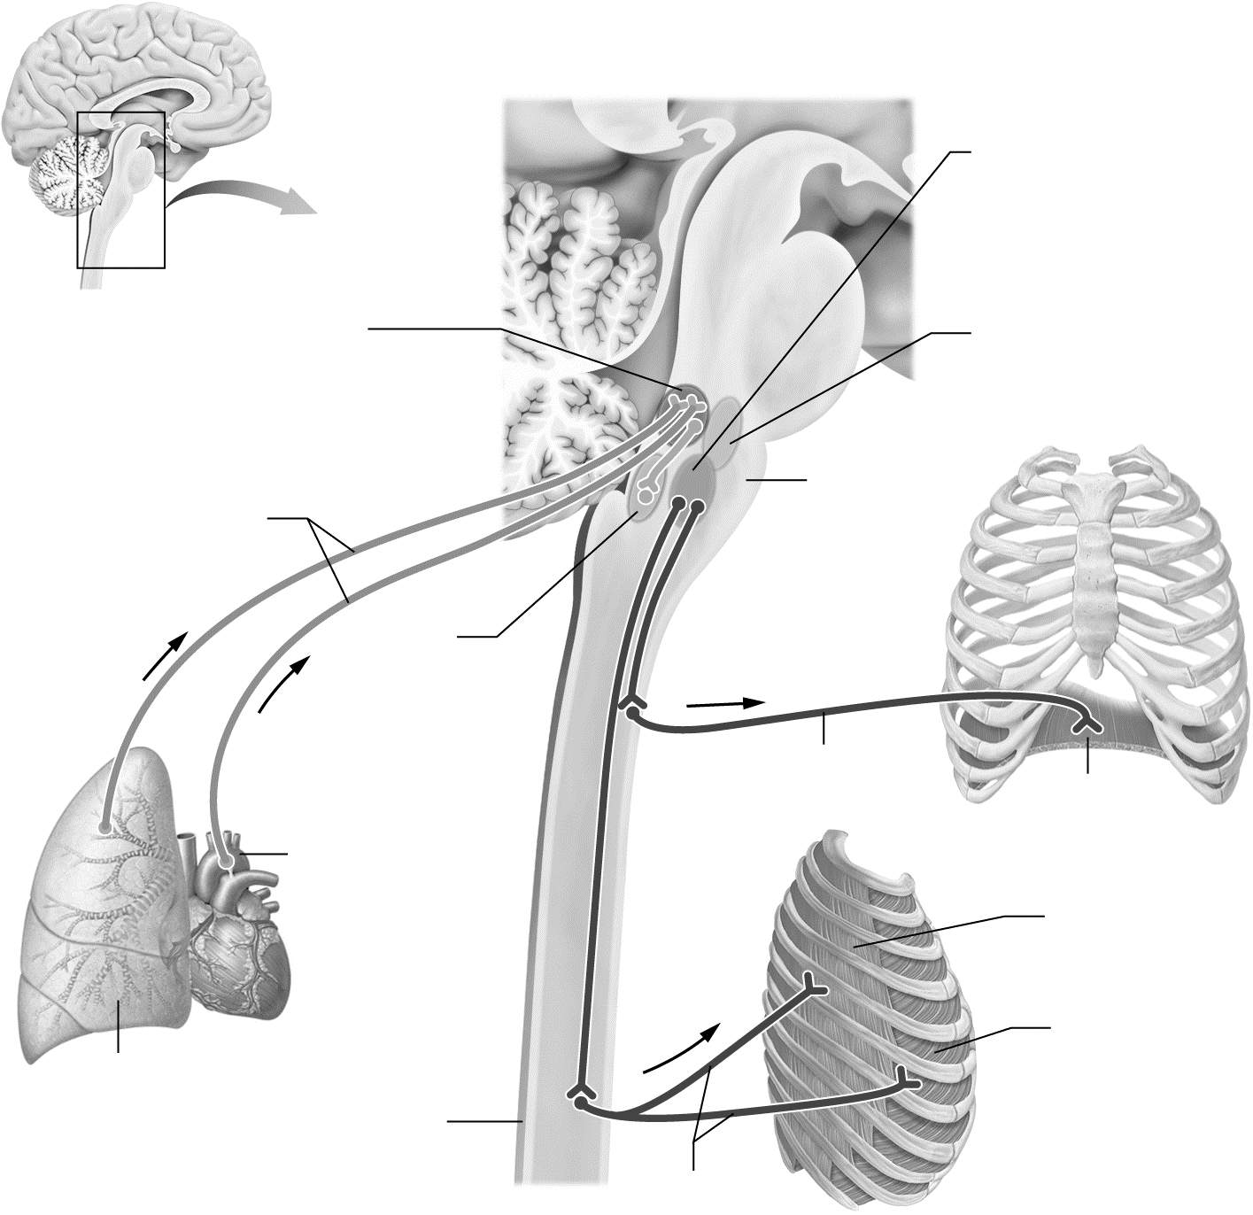

Figure 21.12 Neural control of the basic pattern of ventilation.
Key Concept: What is the respiratory rhythm generator? Which nuclei work with the RRG to maintain eupnea?

Practice It: Central and Peripheral Chemoreceptors
For each of the following scenarios, determine if the stimulus would be detected by the central chemoreceptors, peripheral chemoreceptors, or both. Then, determine the change in ventilation that would be triggered by each stimulus.
• Decreased PO2
• Increased PCO2
• Decreased pH
• Increased PO2
• Increased pH
• Decreased PCO2
Key Concept: Why is carbon dioxide such an important stimulus for the central chemoreceptors?

Module 21.8: Diseases of the Respiratory System
Now that we have explored the basic concepts of the anatomy and physiology of the respiratory system, we turn to the common diseases affecting this system. When you have finished the module, you should be able to do the following:
1. Explain the difference between restrictive and obstructive disease patterns.
2. Describe the basic pathophysiology for certain pulmonary diseases.
Build Your Own Glossary
Following is a table listing key terms from Module 21.8. Before you read the module, use the glossary at the back of your book or look through the module to define the following terms.
Key Terms for Module 21.8
Term | Definition
Restrictive lung disease
Obstructive lung disease
Chronic obstructive pulmonary disease
Asthma
Outline It: Note Taking
Outline Module 21.8 using the note-taking technique you practiced in the introductory chapter (see Chapter 1). (The template is available in the study area of Mastering A&P.)
Try It: Obstructive and Restrictive Diseases
To experience the feeling of both a restrictive and an obstructive lung disease, obtain a regular-sized drinking straw and put one end in your mouth. To mimic the feeling of a restrictive disease, inhale as deeply as you can through the straw (pinch your nose closed so you don’t cheat). To mimic the feeling of an obstructive disease, take in a normal inhalation (not through the straw), then put the straw in your mouth and exhale through it (again, pinch your nose closed).
Practice It: Obstructive and Restrictive Lung Diseases
Would the following pulmonary volumes and capacities be expected to be abnormal in an obstructive lung disease, a restrictive lung disease, or both?
• Vital capacity
• Functional residual capacity
• Residual volume
• Inspiratory capacity
• Total lung capacity
Key Concept: What is the key difference between a restrictive and an obstructive respiratory disease?


What Do You Know Now?
Let’s now revisit the questions you answered at the beginning of this chapter. How have your answers changed now that you’ve worked through the material?
• What is/are the main function(s) of the respiratory system?

• How do we breathe?

• Why do we inhale oxygen and exhale carbon dioxide?

Next Steps
You’ve just actively read your chapter, so now it’s time to start your Bring It Back practice sessions. What types of Bring It Back practice will you use to study the respiratory system?
__________________________________________________________________________________________
__________________________________________________________________________________________

The respiratory system has a lot of interrelationships with previous material, particularly blood and the cardiovascular system. How can you Mix It Up to enhance your understanding of earlier material and current material?
__________________________________________________________________________________________

__________________________________________________________________________________________
How well have you been managing your time in the last few weeks? Is there anything interfering with your ability to Space It Out as recommended? If so, how can you work around it?
________________________________________________________________________________________________
________________________________________________________________________________

We’ll see you in the next chapter!

